Researching a child’s embodied textual play
Kerryn Dixon and Hilary Janks
University of the Witwatersrand

Introduction
The focus of this chapter is to describe our methods for researching children’s texts and literacy practices as part of an overarching project on the spatialities and embodiments of childhood. This project investigates the spatialities of childhood through teachers and researchers’ work with children in early years’ classrooms and the home environment. Our work is located at the interface between habitus (Bourdieu, 1992) and habitat.
As critical literacy educators we are interested in the ways children develop agency. Critical literacy has moved from a focus on oral and written verbal texts to a focus on multimodal texts that use a range of signifying systems, such as images, sound, gesture, movement and materials. Changes in technology have brought about a concurrent shift from print to screen that enables the simultaneous use of multiple messaging streams. What counts as a text has, as a result, broadened considerably (Bearne, 2003) and now includes amongst other things, artifacts (Pahl and Rowsell, 2010), and places and spaces (Comber, 2015). They exist in a wide range of genres and forms such as art, drama, dance, books, artifacts, and construction. We present data from an ongoing ethnographic study now in its second year, which is part of our overarching project. Leah, a six-year-old middle class girl is the focus of our study, and here we examine the out-of-school texts created during collaborative play. In this chapter we explore the inter-relationship between Leah’s embodied digital and print literacies in her construction of texts.
Much of the current research in early childhood that is concerned with digital technologies (e.g. Burnett, 2010, 2015; Harwood, 2017; Flewitt, Messer and Kucirkova, 2015), is located in the political North. Although Leah is a child with privileged access to digital technologies at home and is comfortable with both old and new technologies, this is not the case for most children in South Africa. In addition, the take-up of digital technologies in our K-3 classrooms has been slow. While our context makes it necessary for us to continue to research the use of old technologies in childhood education, we are firm believers that they provide varied opportunities for learning in early childhood and are worthy of ongoing research in their own right (Crescenzi, Jewitt and Price, 2014). Research focussing on digital technologies only, runs the risk of not recognizing the importance of the interplay between different technologies and how children traverse the landscape of technological possibilities to suit their purposes and current levels of technological competence. Kress (2004) argues that children’s choices relate to the affordances of the different modalities, but we contend that children’s embodied understanding of their own competence and sensory pleasure are as important.

Theoretical approaches that underpin our work
To understand Leah’s textual play, we first foreground the theoretical approaches informing our work. These approaches influence the ways in which we design our research, enable us to make sense of our data, and position our work in relation to the debates in the field.
We draw on three bodies of theory in our work with children, as well as research located in these paradigms that focuses on young children’s engagement with digital technologies:
- Socio-cultural theories of literacy and play in early childhood (e.g. Dyson, 2016; Edwards, 2013; Harwood, 2017; Larson and Marsh, 2013; Wohlwend, 2008, 2015) together with theories of multimodal representation (e.g Rowsell and Harwood, 2015) and transmediation (e.g. Kress, 2004; Newfield, 2015);
- Theories of childhood (e.g. Dahlberg and Moss, 2005; Edwards, 2013; James and Prout, 2015);
- Theories of embodiment in time and space (e.g. Dixon 2011; Farman, 2015; Foucault, 1977, 1980; Lefebvre 1991, Thiel, 2015).

These theories come together as we try to understand how literacy is embodied in a particular child in her textual play.

Reflections on research methods
Collaborative play as a form of ethnography
There is a long history of using ethnography in literacy research. The advantage of an ethnographic approach is that it provides insights into beliefs and practices observed over time, is socially situated, data collection is flexible, unstructured and guided by participants, and themes for analysis arise from the data. Ethnographies have been critiqued for the impact researchers have in the site and that researchers do not reflect reality, but create it through their subjective writings.

All research choices are subjective, but ethnography provides opportunities for researchers to reflect on their perspectives. It demands that researchers, ‘think consciously about entering the life of the other’ (Heath and Street 2008). We have been influenced by participatory research and participatory methods with young children (Clark and Moss 2011; Fargas-Malet et al 2010; Literat, 2013; Mand, 2012; Tay-Lim and Lim, 2013). This approach has been shaped by changing conceptions of childhood that see children as ‘experts in their own lives’, ‘skillful communicators’, ‘rights holders’ and ‘meaning makers’ (Clarke and Moss, 2011, p.5). But as Gallacher and Gallagher (2008) point out, although acknowledging children as having agency and constructing children as co-researchers and knowledge-producers, research agendas using participatory methods are most often adult-driven, do not take power relations into account, or acknowledge the dynamic nature of children.

We have thought carefully about the benefits of participant observation in ethnography, what participatory methods bring to an ethnographic approach, and how best to enter the life of a child as adults. Dyson’s (2016) contention that play is the work of children is important. Our interest in what happens in children’s ‘textual playgrounds’ where children respond to each other, ‘adapt relevant symbolic material, assume complementary roles, and thereby, construct a textual encounter’ (Dyson 2013, p. 117), led us to consider how, instead of using a more traditional form of participant observation, our entry point into Leah’s life could be through collaborative play. Collecting data through collaborative play is similar to, but not the same, as participatory research. There is no research agenda. The questions emerge from what transpires during play. Collaborative play is child-directed.

Thus, emic and etic perspectives become important. Collaborative play is an approximation of an emic perspective. Hilary, Leah’s collaborative playmate, is an ‘insider’ in terms of her access to and knowledge of the family and culture in which Leah is located. But she cannot be considered a full insider, because she is not a child. If researchers want to understand children’s play, it is important to see what they do, not how they comply with adult direction. This is easy to say and hard to do. Thiel (2014, p.130), in describing her experience as a researcher learning to play with a child in an out-of-school space, says,
Perhaps reflecting years of my body/mind being territorialized by discourses of what it means to be a teacher in the presence of a child, I felt like I had to “teach something” rather than letting [the child] lead me.
Influenced by Thiel, Hilary realised that she had to unlearn her own embodied pedagogical inclinations and give up ‘hierarchy, power and the binary of adult and child’ (Thiel, 2014, p.121). She had to recognize that her own body had been schooled to be a pedagogue rather than a playmate or a researcher.
Collecting data ‘as a playmate in the moment’ is complex. It is challenging to write fieldnotes, or videorecord in the moment, whilst playing. So Kerryn acted as an ‘outsider’. She interviews Hilary and Leah, and watches recordings of the play to interrogate what, how, and why things happen. Interviews with Leah are related to the texts she produces. Those with Hilary are about the textual products, reconstructing the play, probes on how meaning was made and remade over time, and recursive connections to other digital and print texts and play dates.
Because our focus is Leah’s textual play, this research requires an analytic focus on the texts. Flewitt’s (2011, p. 297) work combining ethnography and multimodality is helpful. She argues this combination can lead to the
production of grounded, theorised, detailed and holistic insights into literacy as a social practice, revealing how micro-moments of multimodal meaning making unfold in a complex network of socially situated norms and practices.
Because texts can only be understood in relation to the social and material conditions and the processes of production and reception, our method of text analysis relies heavily on ethnographic data.

Text Analysis
Texts that children produce give us insight into what they are thinking and feeling. They are an externalisation of their embodied internal worlds in material form, and often reveal more than what children at different ages can express in words. By observing the process of production, it is possible to see how ideas develop and change and how the materials interact with the child and influence their thought processes. Children often talk aloud while playing. Following children’s talk provides access to their internal worlds. Materials and technologies are part of the context and conditions of production, as is the participation of an adult in the play. Understanding that the text is produced in relation to material and social conditions is an important part of textual analysis. Fairclough’s approach to discourse analysis requires us to consider both process and product and the material and social conditions that affect what children make, and how they make them. Figure 1 combines elements of his 1989 and 1995 model versions.

Figure 1 Fairclough’s Dimensions of discourse (1989, p.25; 1995, p. 98)
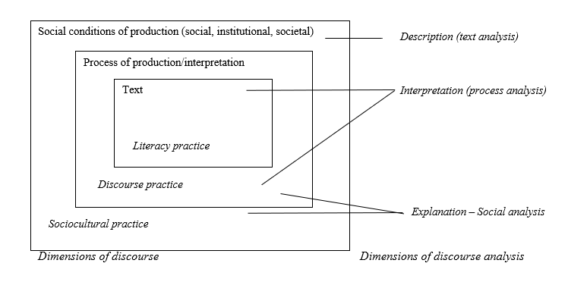
Data collection methods: ‘Will you take a video of me explaining this?’
In two years we have collected a large and varied data set (see Table 1). The data comprises: fieldnotes, photographs of texts during production and as final products, interviews, artifacts and videos of Leah playing which are often performative: she encourages Hilary to film her talking about her texts. Each item is interesting, but as a body of longitudinal data it reveals Leah’s developing motor and perceptual skills, language development, growing knowledge of herself and the world, visual literacy and performativity from her engagement with movies. It becomes possible to see recurring motifs and shifting embodiments.

Table 1 Data collected over a two-year period
Data | Description | Recorded
Drawings | 7 large scale drawings about 86 cm by 73 cm that Leah calls ‘maps’. | Original artifacts, photographs and video during making, field notes
Created books | 3 books (11cm x 15cm) with a varying number of pages. | Original artifacts, scanned copies
Construction projects | A range of materials are used (e.g. Lego). | Photographs, field notes
Leah performing | Leah and Hilary act out books, improvise movie story lines. Toys/action figures are also used. | Video, field notes
Material artifacts used in play | These include dress up costumes, toys. | Original artifacts, photographs, video
Media | Movies, audio and print books, game apps, YouTube videos, DVDs. | Screen grabs from iPad, lists of digital and print texts
Interviews and conversations | Unstructured on-going interviews with Leah, Hilary Conversations with Leah’s parents (for fact-checking). | Transcribed, written notes in situ

In following an ethnographic tradition, it is important to construct thick descriptions. Below is an excerpt of a thick description of Leah and her literacy practices:

Leah is an emerging literate who is steeped in children’s movies, children’s television and books. As yet she is not able to read and is more interested in learning to write than to read. She has many children’s books at home, which in addition to Hilary’s own collection, she enjoys. At the time of writing, her iPad had 30 movies, 30 audio books and 44 games on it that her parents had chosen, vetted and downloaded for her.
Leah’s iPad travels with her. She wakes very early and can play with it until the alarm goes off at 6h00 or 7h00 depending on whether or not it is a school day. She can operate this technology with confidence, is adept at opening folders, inserting her headphone, adjusting the volume, the size of the image and the orientation of the screen. She knows how to switch to pause, to mute, to fast forward and to rewind. This knowledge is so embodied that she does not have to think about what to do.
In addition to the iPad, her parents take her to the movies regularly, and have downloaded countless movies and children’s television programmes from Netflix, which she can ask to watch on the TV screen. She can use a television remote confidently. She has watched many of Hilary’s DVDs of Willems’ books: including Don’t let Pigeon drive the bus (2003), Pigeon finds a hot dog (2004), Duckling gets a cookie (2012). Movies are without question her favourite genre and what she engages with the most. Some movies she watches over and over. She seems to enjoy different movie versions of the same story as well as the same story in book form. She has toys of the characters from many of her favourite movies and books. Her immersion in narrative texts has given her a wide range of resources for imaginative and linguistic play.

Data analysis: a bird’s eye view
An ethnographic approach combined with a focus on multimodal texts generates a large body of data. This presents a challenge in making principled decisions of how much data needs to be included and at what level of detail. Selection should be representative of the data and not cherry-picked. This is made more difficult because what methods or approaches enable one to ‘capture, define analyse, and represent the meaning potential of interwoven, diverse semiotic modes’ (Flewitt 2011, p.295) has not been clearly established.
Having the perspectives of two researchers in constant conversation about the data is an advantage. We find ourselves returning to certain incidents and themes. Reading the literature in the field provides insights; our understandings of Leah and her play grow over time; and in comparing different data sets and new data we realise how partial some of our understandings are, and what we just got wrong. One of the ‘issues’ we kept returning to was how the character of Pigeon from Willems’ Pigeon books regularly inserted himself into Leah’s world. We use the ‘Pigeon data set’ (see Table 2 for a visual summary) to answer the emerging research question:

What is the inter-relationship between Leah’s digital and print literacies in her construction of texts during collaborative play and how are these literacies embodied?

Table 2 The Pigeon data set
Leah’s and Hilary’s texts produced in collaborative play
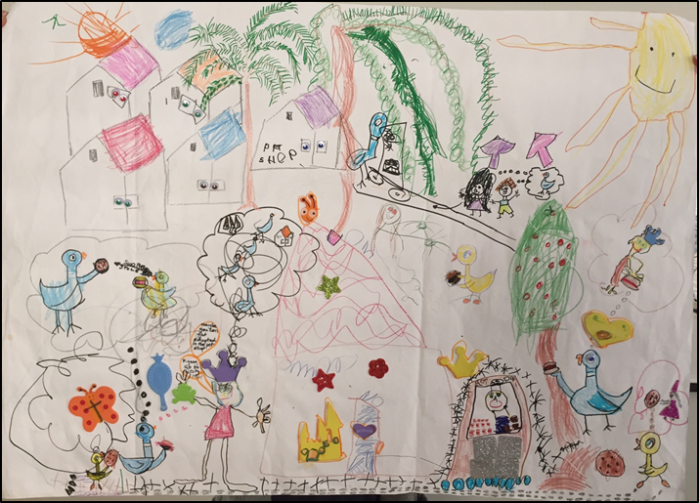  Map: Pigeon and Duckling  give the Princess something |  |  |  | 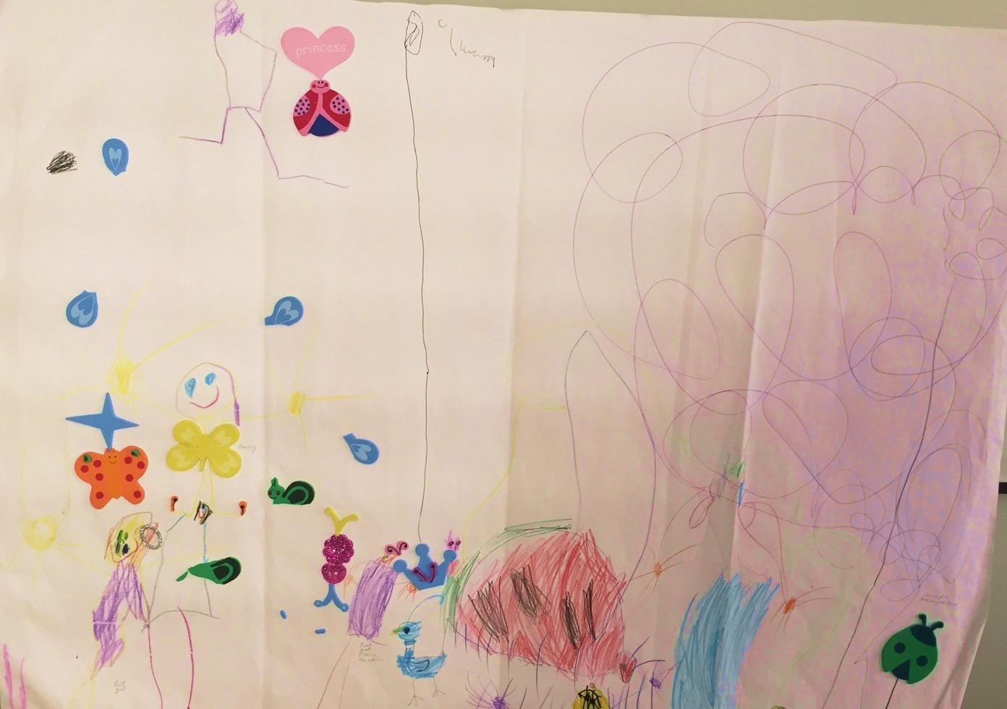  Map: The story of the stolen crown
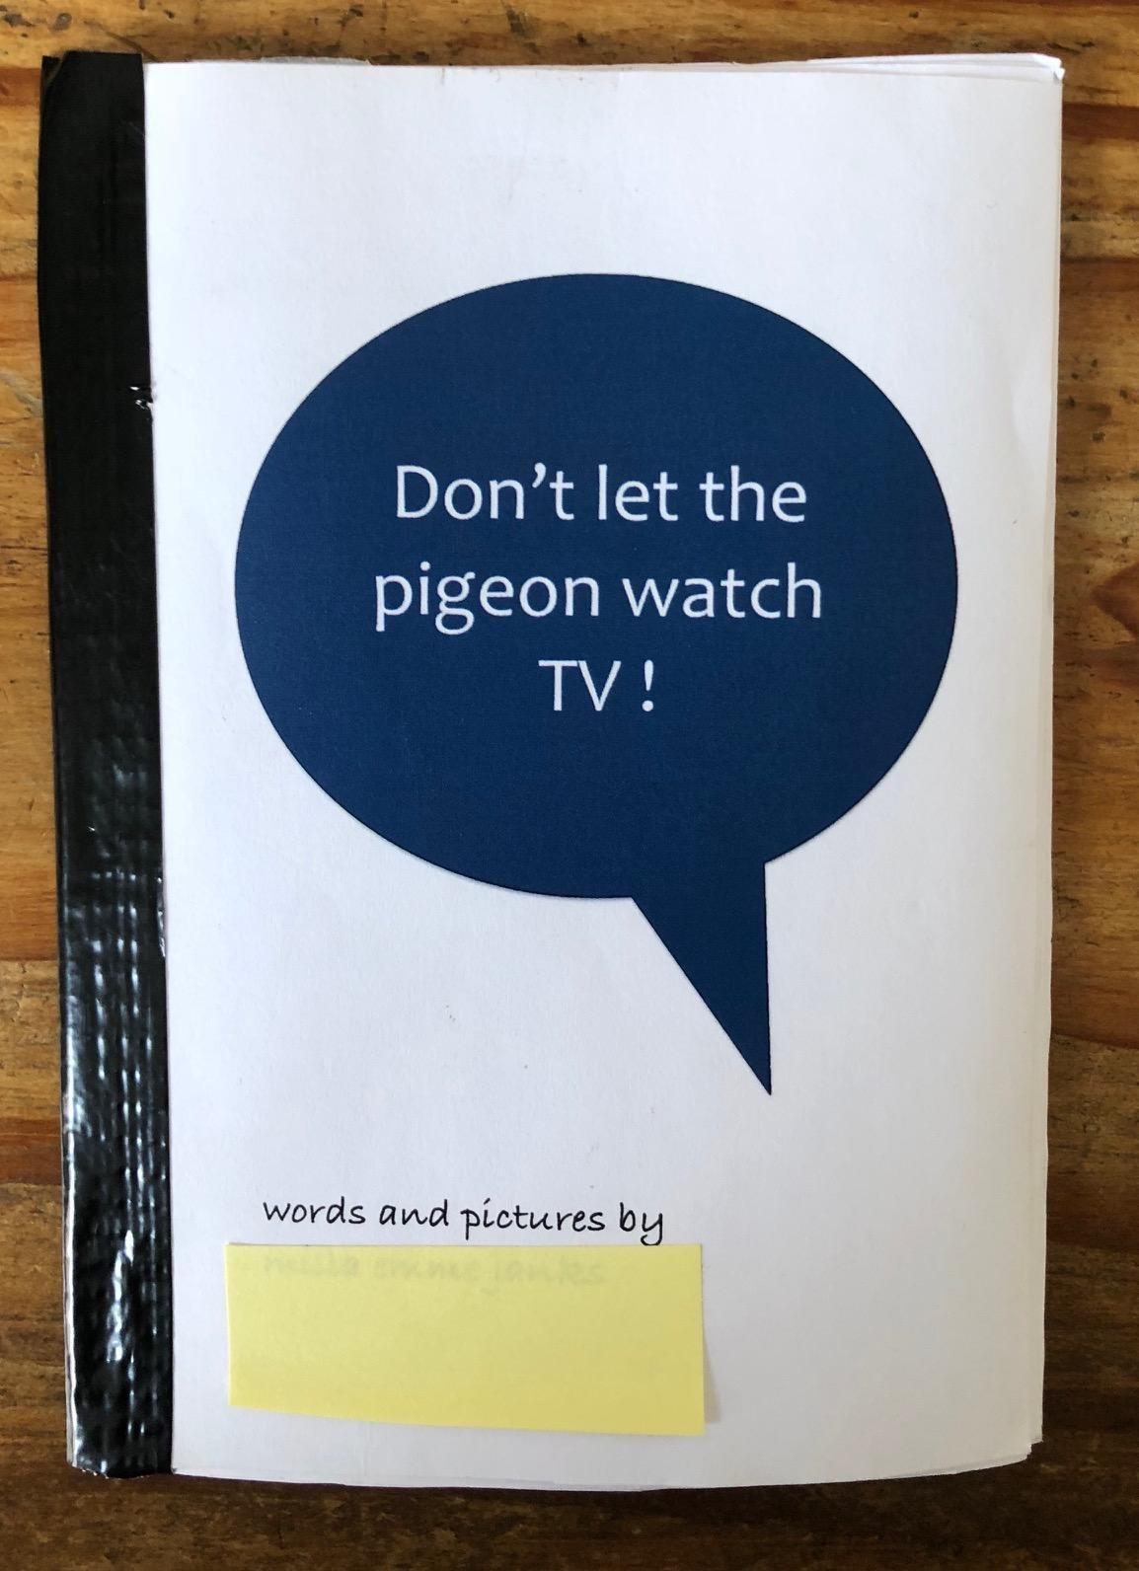  Leah’s first Pigeon book |  |  |  | 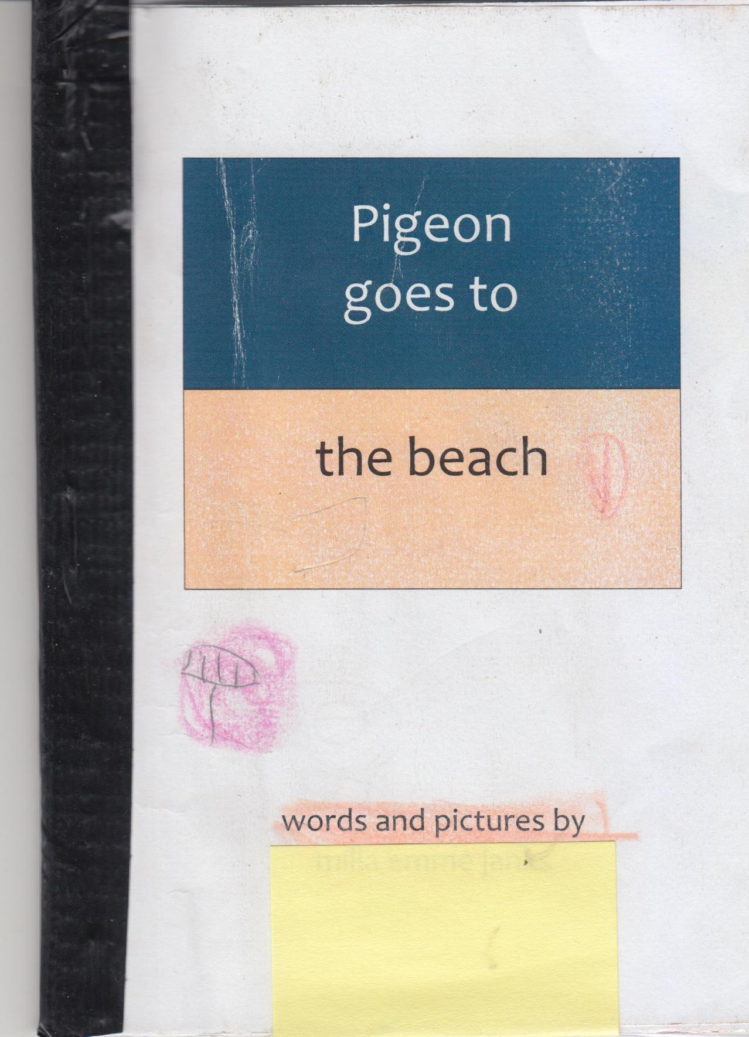  Leah’s second Pigeon book
Data generated by Hilary
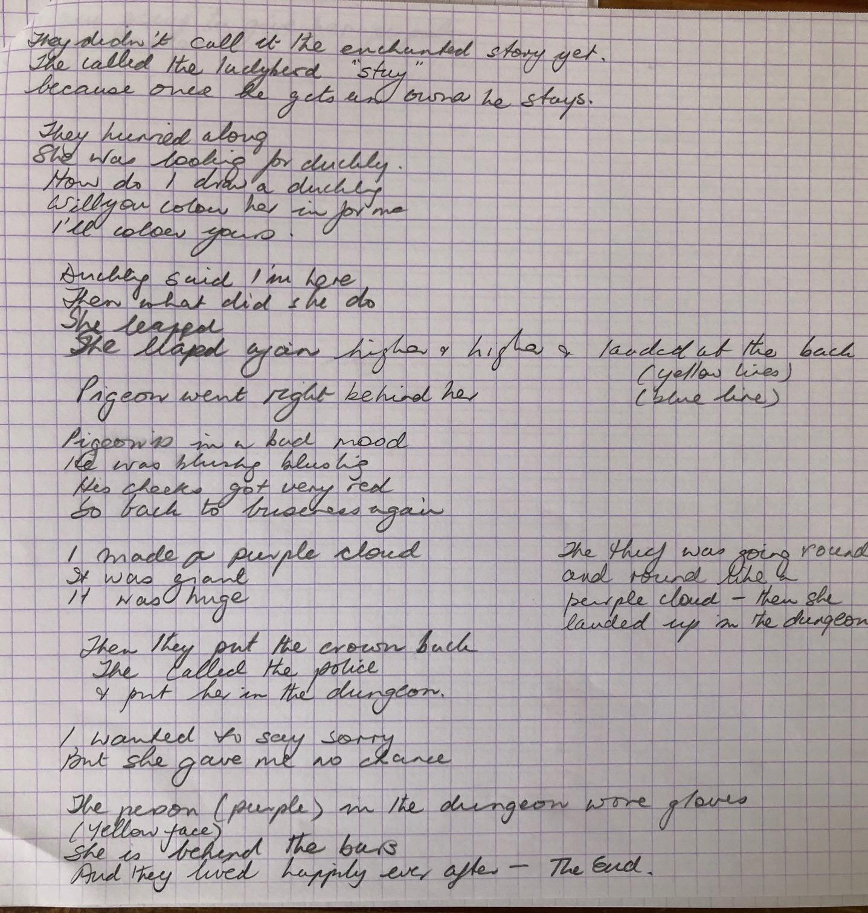  Fieldnotes | L: You can see the storm clouds.  R: Huh?  L: You know like in a comic, when they draw a dark cloud over someone’s head.  Interview transcript |  | 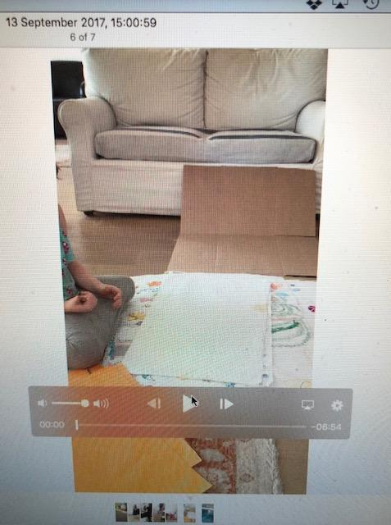  Video |  | 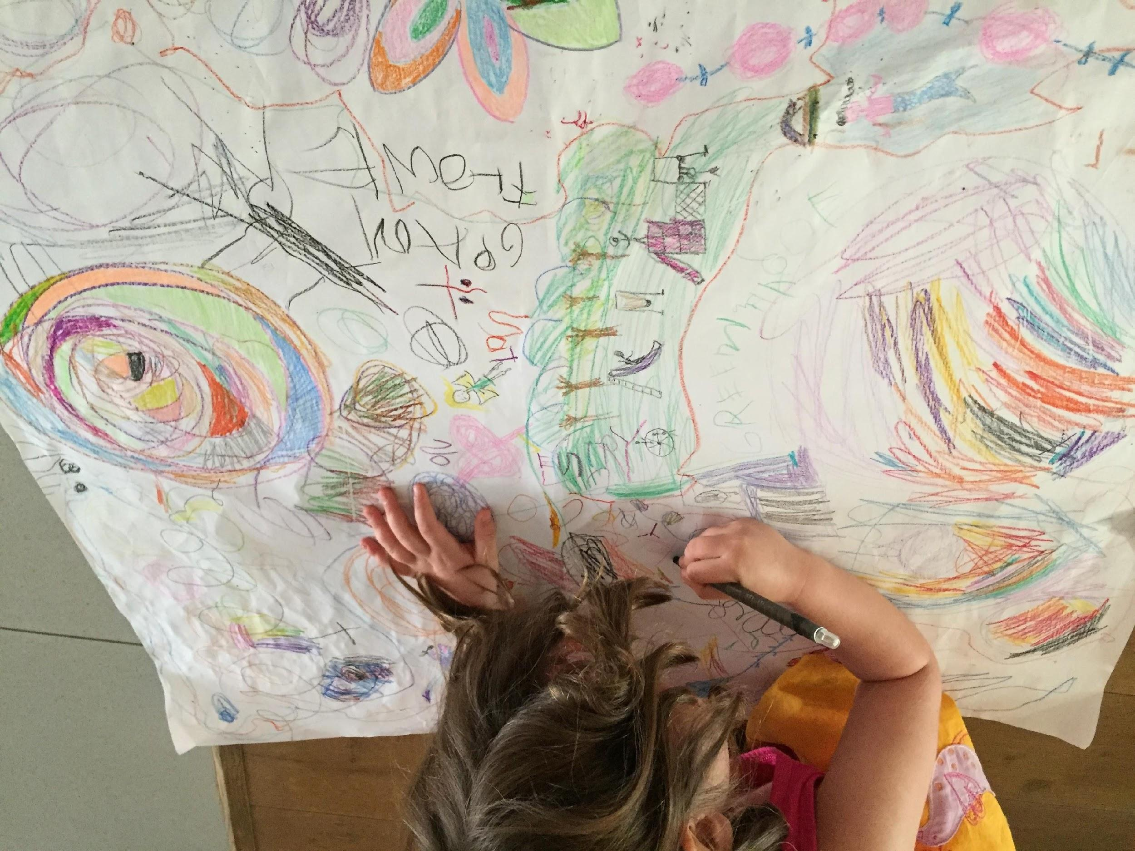  Photograph
Print, Multimedia, and On-line texts
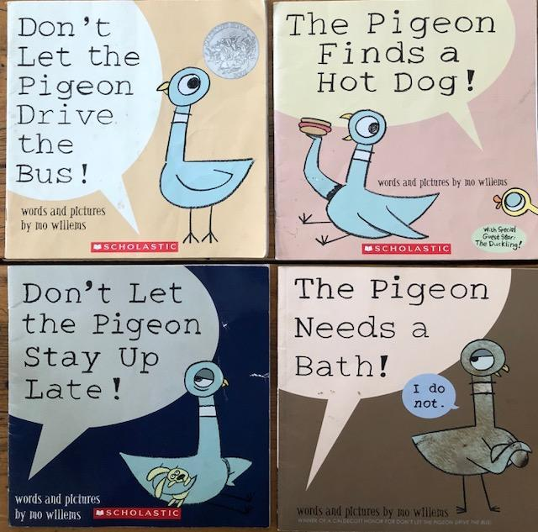  Willems’ Pigeon books |  | 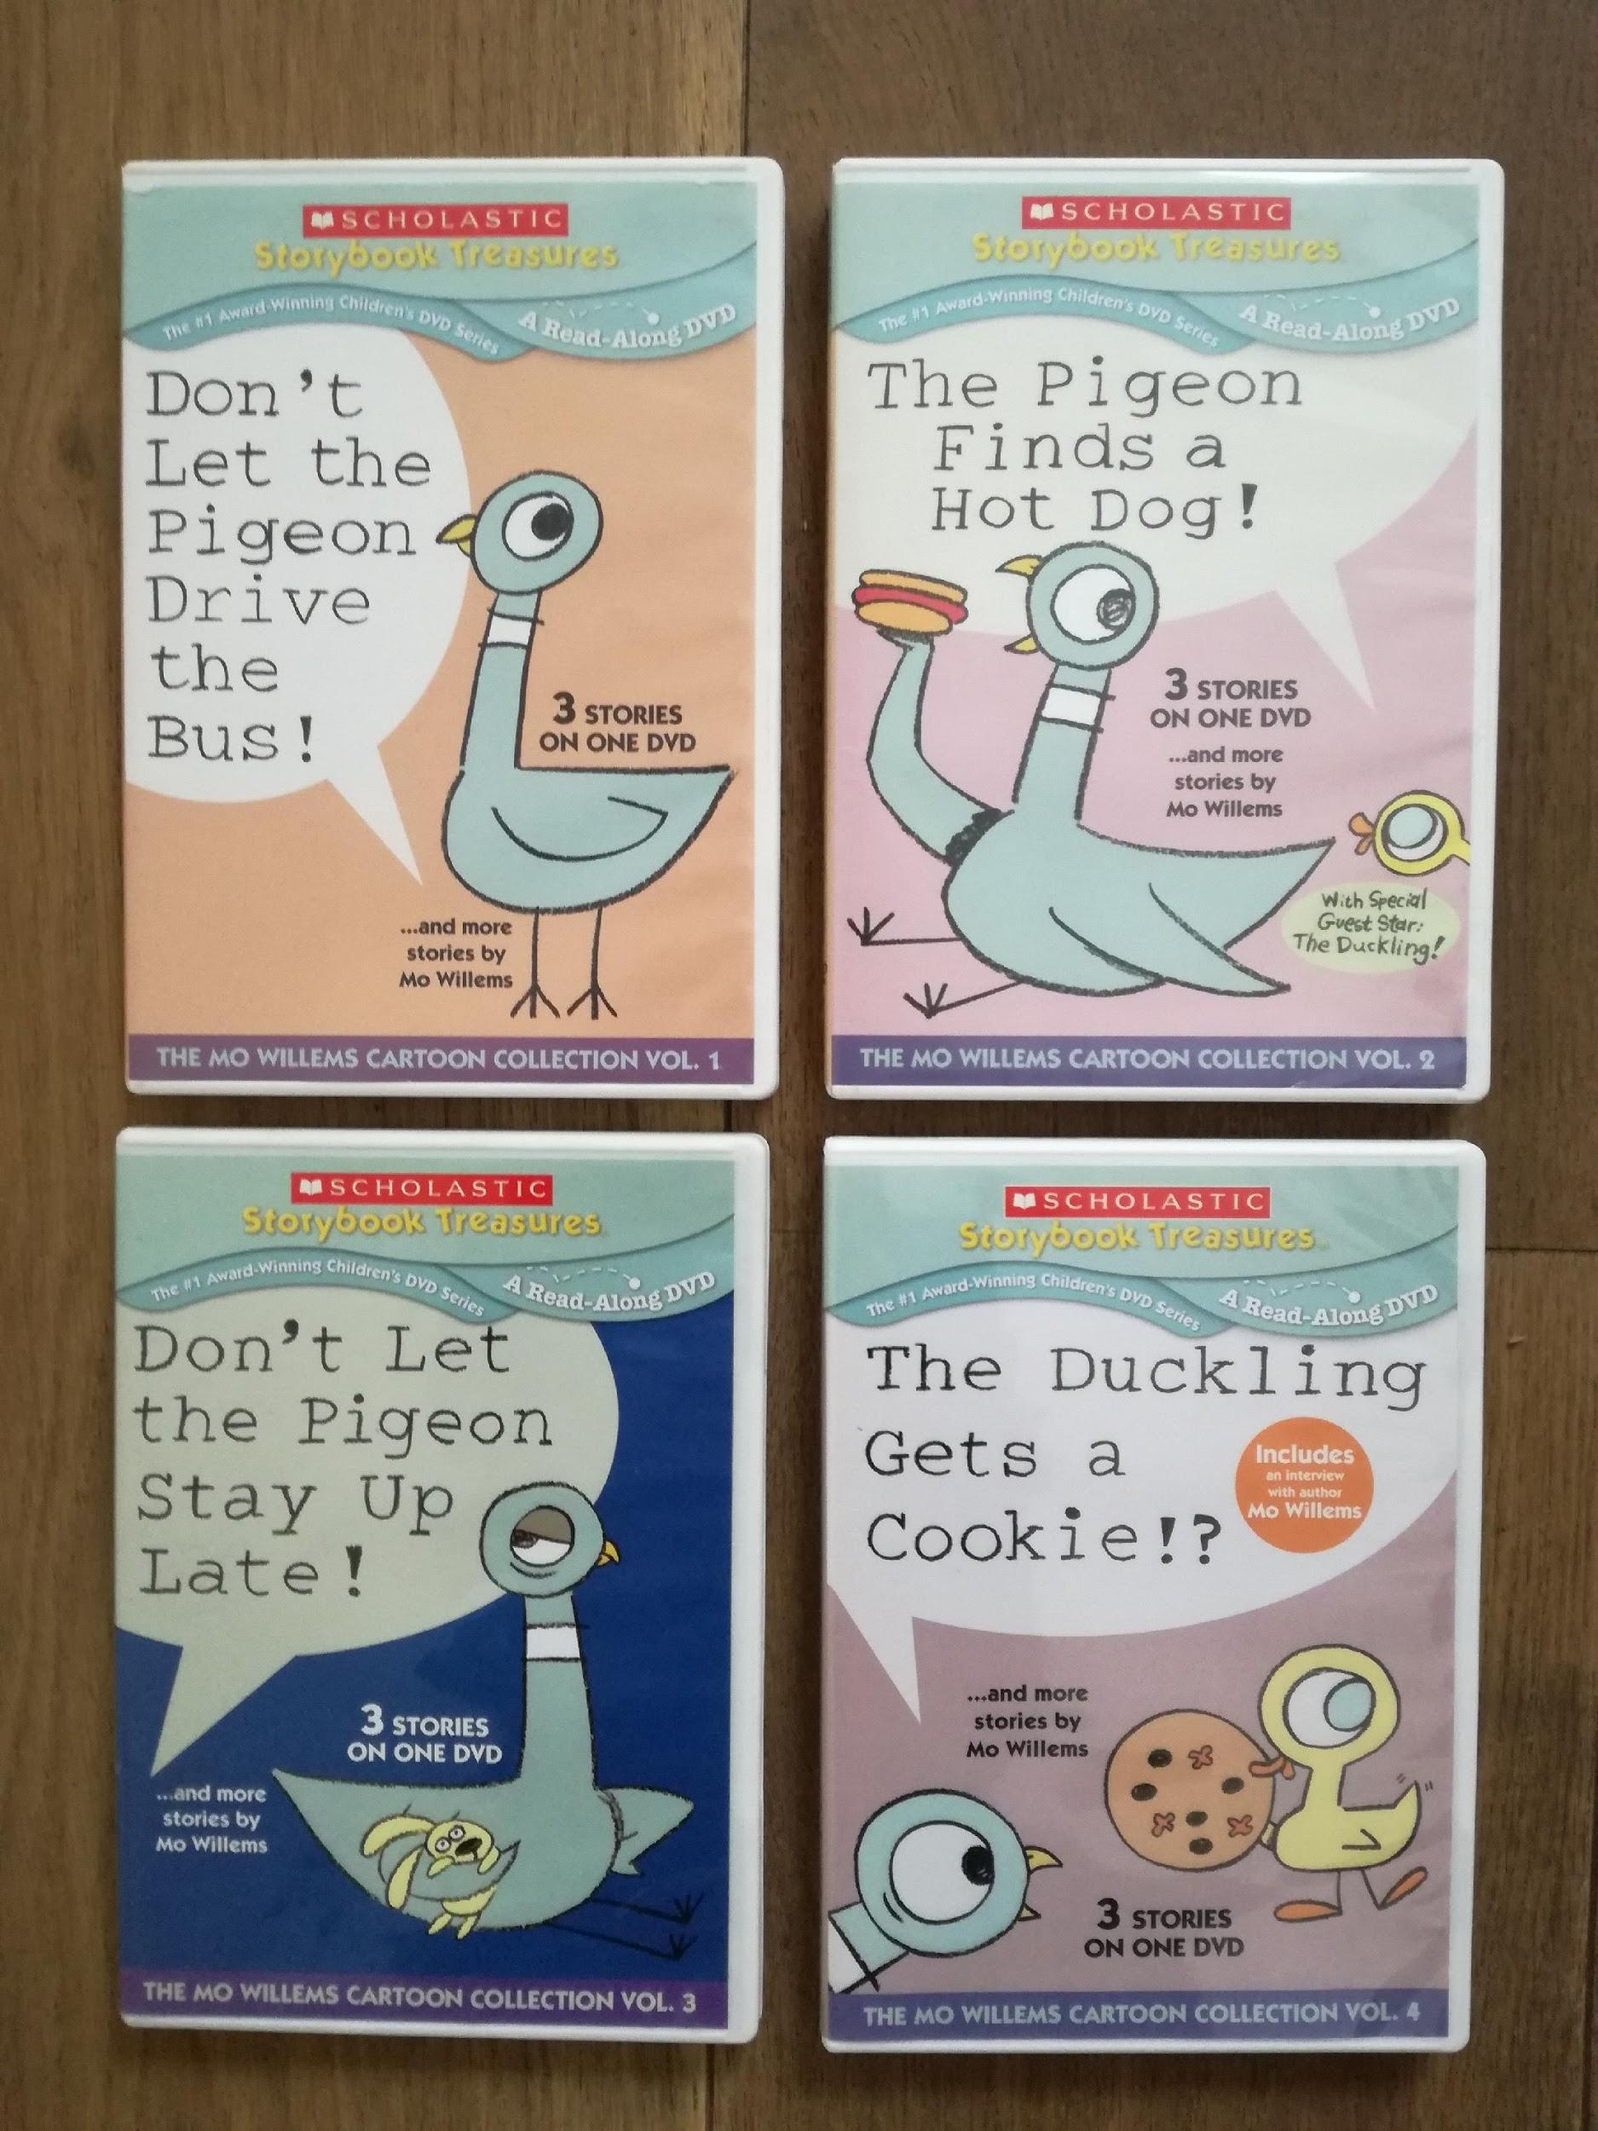  Animated DVDS |  |  | 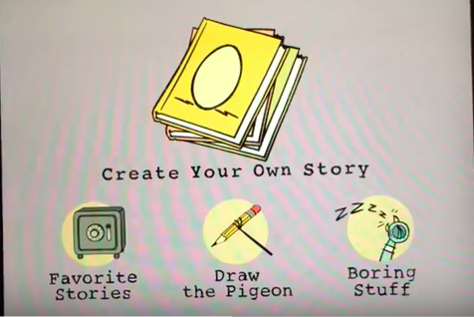  YouTube videos e.g. How to  draw Pigeon (https://www.youtube.  com/watch?v=NG7_P1kT-7U&t=36s)

Fairclough’s approach to analysis allows us to integrate the questions arising from our ethnographic analysis and our theoretical framework into his model. Our adaptation of Fairclough’s model is represented in Figure 2.

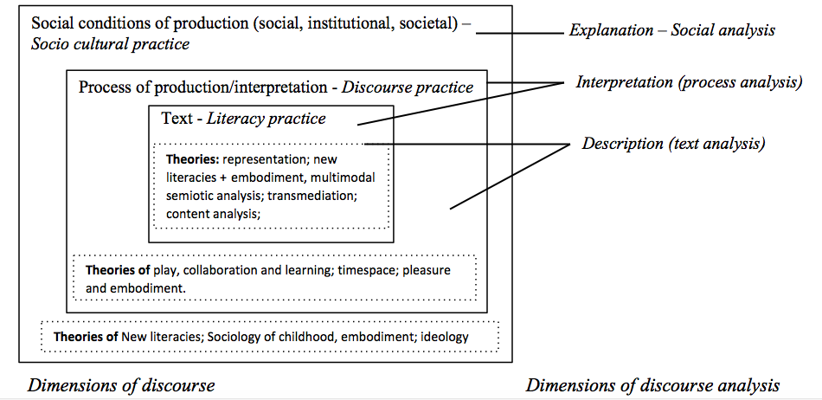
Figure 2 Fairclough’s model with theory inserted relevant to this study

Analysis of the conditions of production and reception
The Pigeon maps and books produced by Leah could not have been imagined without extensive knowledge of Willems’ stories. Hilary has read the Pigeon books aloud so many times that Leah almost knows them off by heart. When she subsequently and repeatedly watched the animated versions of these stories on DVD, her knowledge of plot, setting, narrative, dialogue and characterization were reinforced and extended. We argue that the middle-class literacy practice of being read-aloud to is deepened by watching and listening to the same stories on DVD, a digital literacy practice. The meaning potential of multiple modes (oral, visual, verbal, spatial, gestural) embedded in these literacy practices enhance Leah’s understanding of narrative and text creation. The result is the same as noted by Rowsell and Harwood (2015, p.139): When ‘children design texts by layering personal interests, experiences, and histories with media driven understandings, more universal texts tend to emerge.’
Leah finds the books funny and takes great pleasure in the humour created by Pigeon’s behaviour in the videos. The stories talk to childhood experiences of food, bedtime, bath-time, sharing, and fantasies of doing grown-up things. Pigeon, who represents the ‘hard-done-by’ child, tries to get what he wants by sulking, pleading, cajoling, bribing, whining, complaining, guilt-tripping and throwing temper tantrums. Children find it hilarious to see their own behaviour in Pigeon, as evidenced in Willems’ video-recorded engagement with child-audiences (see extra feature, ‘Mo and Pigeon visit a school’, in Weston Wood Studios’ 2010 DVD, Don’t let the Pigeon Drive the Bus). In this feature, Willems models ways of getting children to interact with the stories, as the responsible child who refuses Pigeon’s demands. Leah loves loudly shouting, ‘No’, to Pigeon’s demands when the books are read to her and her whole body responds. This embodied engagement finds expression in her drawings of children responding ‘No’ to Pigeon in her artwork (Figure 3) for her first Pigeon book, Don’t let the Pigeon watch TV. The capitalised and extended ‘Nos’ are an example of transmediation.

Figure 3 Leah’s artwork of children responding ‘No’ to Pigeon.
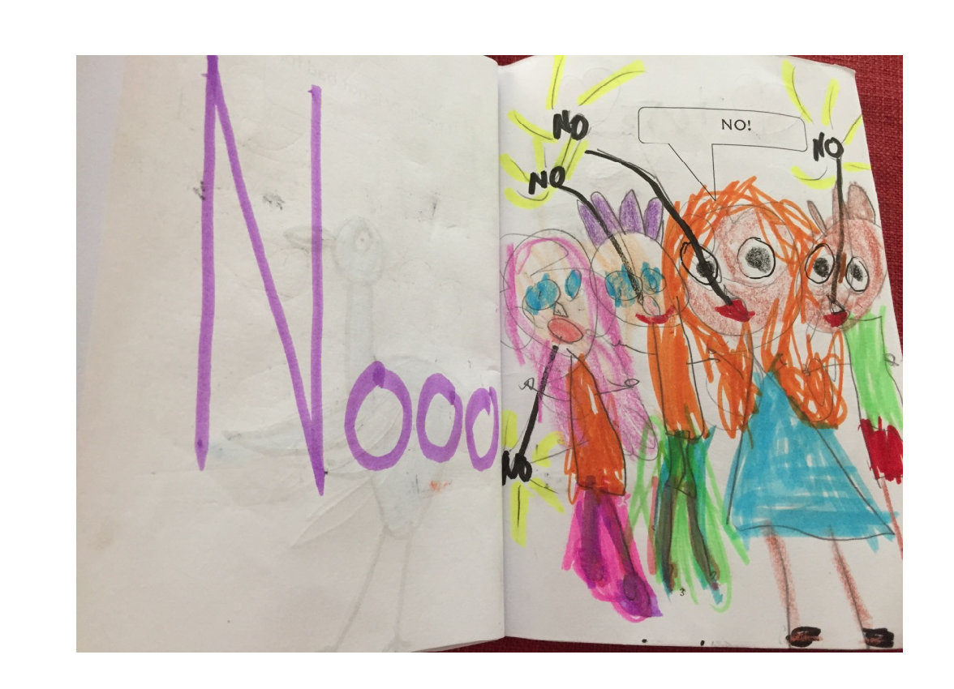
The positioning of children as ideal reader-viewers requires a superior disposition that laughs at Pigeon’s foibles. Leah continues to embody this disposition as she takes on the role of writer, which enables her to replicate Willems’ satirical tone. Her access to digital technology affords her access to the author with his texts. Willems explicitly encourages children to make up their own stories and teaches them how to draw his characters. The normalised practice of access to information in on-line spaces, and fluid boundaries between text ownership, benefits Leah as a writer/creator in the off-line time and space she inhabits.
Leah’s experience of Willems’ books and videos are deepened by her engagement with other genres, modes and media. The Disney Princess films provide fertile ground for her creative imaginings in her Pigeon maps. These maps (see Figures 4-6) are examples of
‘Big worlds’ with rich literary resources, such as engrossing narratives and memorable characters for ‘thick play’, that is, repeated intensive and extensive playing and replaying that develops deeper literary understanding (Wohlwend, 2015, p. 548).
Hilary is implicated as a ‘player’ in the conditions of production and reception; and following ethnographic practice, this needs to be acknowledged. Hilary’s academic knowledge of literacy and childhood and practical experience of children’s literature, movies and the internet, brings her own cultural and embodied capital (Bourdieu, 1992) to this play. She had to develop a meta-cognitive awareness of her embodied tendencies to teach while playing. She makes a range of spaces and material resources available for different forms of play. Leah prefers different spaces for different forms of play and spends variable amounts of time on her textual projects depending on her interest level.
The most important conditions of production of these maps and books are extensive exposure to the original texts across different modes and media, with engaged participation alongside Hilary.

Analysis of the processes of production
Leah doesn’t always choose textual play. When she does, she decides what and where they should play. She decides when she has had enough or whether she wants to go back to work on something they worked on before. Often, she takes a break and returns to her chosen project the same day. At other times, she may spend several hours across different days on one project. Hilary has created an art box for Leah with a range of materials. What is in the box changes, but consistently includes:

Drawing implements: pencils, pencil crayons, wax crayons, felt tip pens
Cutting and sticking: scissors, glue sticks, masking tape, sticky tape
Paper: white and coloured A4 sheets, patterned paper, coloured post-its
Stickers: coloured dots, stars, children’s themed stickers, rubbery sheets of glitter paper, foam stickers.
Drawing Maps
The map paper is stuck to the floor with masking tape. Leah likes to work on a large ‘canvas’ where there is room for two people to play (Figure 4). The organisation of space and time enable particular forms of embodiment. A large ‘canvas’ requires a large work space which creates opportunities for collaboration. Working on the floor enables greater efficiency of movement compared to moving around a table. This spatial organisation enables bodies to lie down, stretch over and across the page, create a large sweep of lines, and tiny fine-grained details. The ‘canvas’ size offers the possibility of a time-dense project, that can sap a body of energy, but also fires the imagination, compelling an artist to return time and again to fill in the details of a complex narrative landscape.

Figure 4 Leah at work on a Map
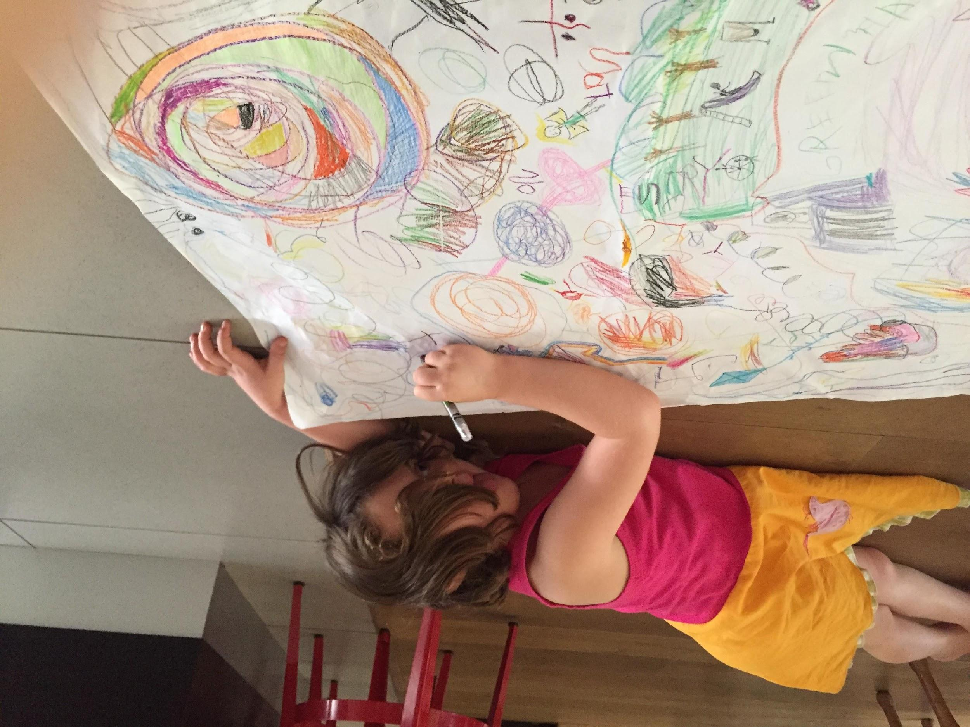

Leah’s first Pigeon map, Pigeon and Duckling give the Princess something was not completed in one sitting (Figure 5). It began with the amalgamation of two Willems stories, The pigeon finds a hotdog (2004) and The duckling gets a cookie (2012). Hilary was instructed to draw Pigeon and Duckling on the right-hand side of the page, whilst Leah stuck stickers on the other side. The crown and hand mirror stickers prompted her to draw a princess. She then joined Hilary and drew the sun followed by the hotdog stand. Only after that did she decide that Pigeon should give the Princess a hotdog and Duckling should give her a cookie. This led her to draw Pigeon’s Princess-thought-bubble and to work out how to show Pigeon moving from one side of the page to the other, to present the Princess with a hot dog. She represented Pigeon’s journey in pigeon ‘foot’ prints. She asked Hilary to draw duckling’s ‘foot’ prints. The remaining detail was added on a different day.

Figure 5 Pigeon and Duckling give the Princess something

The story of the stolen crown was the next map Leah produced (Figure 6). It has less detail and was completed in a shorter time. Leah began by sticking thick rubbery stickers of the butterflies, the beetles, the hearts and the pink flower-shaped glitter pieces onto the page. The story was built from these. Next, she drew the giant lady bug and the fairy. When she decided to use the yellow butterfly as part of the fairy, she tore off the feelers and added them to the glitter pieces to make another insect. At this stage she was working on an idealised garden with insects and a fairy. However, as soon as she saw the crown, it became the focus of the imaginative play. She drew an evil girl on the left, and then drew two more girls in a row, who represent the same girl, with the last girl stealing the crown. Having taken the crown, the girl jumped straight up in the air to get away, represented by the straight vertical line, and then moved around and around, represented by circling lines on the right of the page. She ended up below the circles. Her head and hands are above Duckling’s blue pond. Finally, she’s at the bottom of the page, below the giant yellow bodied ladybird. The yellow body is cross-hatched to show that she has been caught and jailed. A black felt tip pen makes the bars stand out. Almost everything else is in wax crayon, with the escape route in purple. While Leah wove this imagined narrative, Hilary drew Duckling and her pond, as Leah requested. There was no attempt to include Duckling in the story. In this story the Princess appears in reduced symbolised form as a word (princess) and a crown. The crown shows the use of synecdoche, a sophisticated literary device.

Figure 6 The story of the stolen crown
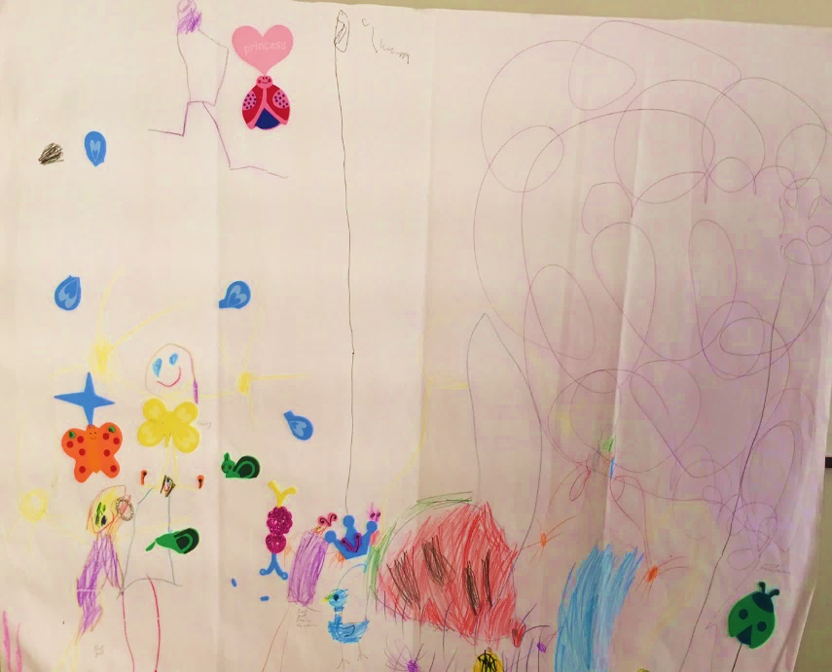

Writing Books
The process of producing Pigeon books is quite different. The spatial logic of creating a book is different to creating a map. The books are produced in three stages and require an upright seated body. In stage one Hilary and Leah sit at the computer and work out the story, which Hilary types with Leah beside her making decisions; then Hilary prints the pages, staples and binds them into a book. In the final stage Leah draws the images to accompany the words, with help from Hilary on request. Hilary took a larger role in the design and development of the first Pigeon book, modelling the process for Leah. Leah’s current inability to type, write and read print mean that she does not engage fully with the technology, but her talk is underpinned by her knowledge of story that comes from the books, an ear for dialogue that comes from film, and an unconscious sense of how dialogue drives Willems’ narratives. Pigeon goes to the beach reads like a script. We’d argue that the oral mode has influenced the genre, and Hilary is more amanuensis than joint author.
Pigeon goes to the beach begins with Pigeon thinking about going to the beach. He approaches the Busdriver and asks if he will take Pigeon there. The Busdriver agrees to drop him off, but doesn’t want to visit the beach himself. Pigeon lists the benefits of the beach, persuading the Busdriver to try it. Busdriver and Duckling, who they meet on the beach, love the beach. Pigeon complains about the hard sand, salty water, big waves, and dogs chasing him. He goes for a swim to cheer himself up but nearly drowns. As Duckling and Busdriver are leaving after a lovely day, Pigeon comments that the rockpools might be better. Busdriver and Ducking, reply: ‘Yeah, Right!’.
A comparison of the books and triangulation with observations and fieldnotes indicates that by the time Pigeon goes to the beach was written, Leah was more confident, and Hilary was better at relinquishing control. Leah needed help drawing most of the bus driver pictures and Pigeon diving into the water. For the rest, Leah thought of the words and did most of the artwork. Hilary had a discussion with her about punch lines; and she chose the ironic ‘Yeah, Right’ for the last page. She has also perfectly captured the spirit of Pigeon’s character.
What emerges again in this description of the processes of production is the importance of engaged collaboration. Leah likes to draw but never undertakes large-scale projects independently. Hilary only draws now for an appreciative six-year-old, even one who makes her do things again when she gets it wrong. It is the shared pleasure of being in the child’s world that sustains the activity. Collaborative play, in this instance, minimizes individual weaknesses and instead a mutually beneficial literacy practice is developed. Wohlwend (2015, p. 549) argues that,
We produce culture when we imagine with others, as we create and agree upon shared ideas of what it means to be and belong in a particular location or to a particular group. Cultures are sustained by shared, automatic, embodied routines.
We also connect interpersonally and deepen our relationships through shared creative endeavours.

Analysis of the texts

Apart from a recent incident where Leah took her own photographs of the text she and Hilary created, Leah’s interactions with digital technologies have been as a consumer. While she is not yet working as an independent creator in the digital domain, the analysis of the two Pigeon maps and Pigeon goes to the beach indicate the influence of digital technologies on her production of texts. What is fascinating is the way in which Leah’s access to, understanding of, and experimentation with genres, modes, and resources result in sophisticated and complex acts of productive meaning-making. Conversations, videos, the stories around text production, and the completed texts themselves, reveal a child whose literate habitus is fundamentally shaped by media and digital technologies.
The inspiration for many of Leah’s textual creations is not story, but materials. Thus, it is important to consider the inter-relationship between technology, materiality, and embodiment. Pahl and Rowsell (2010, p.10) make the case that we need to pay attention to sensory responses and ‘emotional resonance’ of objects. Foam stickers are often a starting point for Leah and she begins the creative process by happily submitting to the agency of the colourful, glittery, sticky materials (Dixon and Janks, 2017). The sheer sensory pleasure of touching, cutting, pulling, sticking, and fingers being stuck to the stickers begins a creative process, that opens spaces for experimentation and exploiting the potential offered by the material (Thiel, 2015).
The crown sticker in Pigeon and duckling give the Princess something cannot operate as a synecdoche unless Leah has access to a range of princess experiences. The princess story is a common trope in her world. Her understanding of princesses has become embodied through multiple viewings of princess movies, playing princess games on her iPad, role-playing princess, and sometimes just being a living, dressed-up princess (Wohlwend, 2009). Leah’s understanding of a princess disposition is succinctly captured in the Princess’s imperious injunction to Pigeon after receiving his hotdog gift: ‘Pigeon go to the pet shop in the city. Maybe you can get adopted as a pet’ (Figure 5).
The crown re-emerges in The story of the stolen crown where Pigeon and Duckling are present in the picture, but do not play a role in the narrative. Evident is Leah’s understanding of the genre conventions of princess stories that she has gained from a range of media: evil characters covet objects from royalty and their plans are thwarted.
Data analysis often throws up unexpected avenues of enquiry. A question that caused a great deal of discussion was the role of Pigeon and Duckling in these transmedia texts. We wondered why Pigeon and Duckling inhabit the world of princesses, but not Willems’ other characters like Elephant and Piggie. We were unsure how to answer this question and returned to the data, literature and theory, talking through a range of possibilities. We explored a number of options: materiality of the texts did not hold up against other data. Ryan’s (2012) concept of the internal logic of possible worlds derived from literary theory was dismissed disdainfully by Leah:
Elephant and Piggie don’t know Pigeon. They are not in the same story. Pigeon is in the Princess’s land and everyone knows the Princess.
The crossover of Pigeon and Duckling into the Princess’ world is influenced by Leah’s interactions with technology: vivid, moving, character-filled films with complex storylines, and Willems’ picturebooks in the media of print and video. The compositional possibilities afforded by the genre of Disney Princess movies finds expression in the entry of other characters into the map worlds. The spatial possibilities offered by the ‘canvas’ mean that more action/complex storylines influenced by film worlds can be captured visually. Pigeon’s and Duckling’s world as created by Willems has much tighter boundaries and limited characters. His composition and style are minimalist, which affects the narrative interactions between characters. These are short and usually limited to two characters. This is evident in Pigeon and Duckling give the Princess something. The map is visually complex but the storyline has limited character interactions: Pigeon and Duckling think about giving the Princess a hotdog or cookie; they walk to her; they change who has the cookie and hotdog; they give their gifts to the Princess; she thinks about the petshop and tells Pigeon to go to it; Pigeon goes; children arrive at the pet shop and think about buying a pigeon. In Leah’s Pigeon books each page has either Pigeon talking to himself, or two characters interacting with one another.
Aligned with this is another more practical point about access and capability. Leah and Hilary don’t know how to draw Elephant and Piggie. They still have to watch the how-to videos and practise.
Learning to produce a book, rather than maps, requires a particular set of bodily skills. As Leah gains more competence and confidence she takes on more compositional tasks. While Hilary drew Pigeon and Duckling in the maps, Willems’ videos taught Leah to draw them. This access to the ‘invisible’ practices of drawing characters, and time to practise, have become embodied. The same can be said of her emergent writing. Presently Leah is experimenting with writing letters and words in relation to pictures (Figure 3) and orally dictating storylines, but this will change. She already considers this ‘my story, not your story’.
Leah’s book shows a level of sophisticated visual literacy informed by the medium of both print and film. She understands how images convey a range of meanings. For example, she can represent the difference between speech and thought using thought and speech bubbles in a medium that lacks an oral mode. She uses speech and thought bubbles in Pigeon and Duckling give the Princess something. Pigeon goes to the beach begins with pigeon thinking about going to the beach which is captured in a thought bubble. Understanding the difference between thought and speech is complex, what is more so, is that these thought bubbles represent desire. They provide insight into the actions and motivations of the characters: Pigeon wants to go to the beach then he asks the Busdriver to take him. The presence of thought bubbles moves the stories out of the literal into the psychological realm.
This affective awareness is also evident in how Leah represents emotions through bodily positions. When Pigeon discovers the beach is not to his liking he is depicted side-on with his wings and head hanging dejectedly; his wings are drawn aloft in the sea when he thinks he is drowning (Figure 7). Leah is a keen observer of techniques used by graphic artists to convey meaning – in commenting on an angry tennis player, she asked if Hilary could see the clouds: ‘you know like in a comic when they draw a dark cloud over someone’s head.’
Figure 7 Examples of Leah using body positions to represent emotions and movement
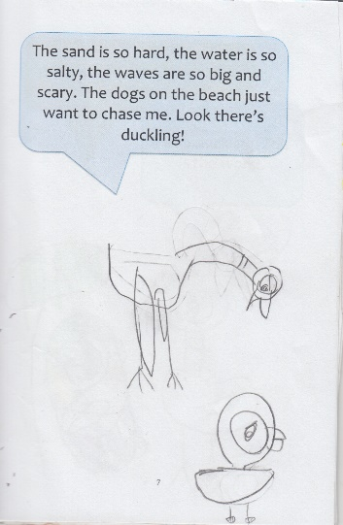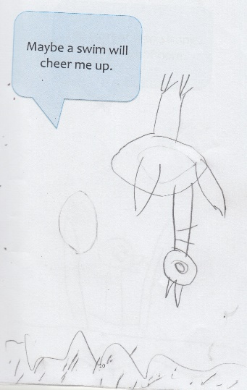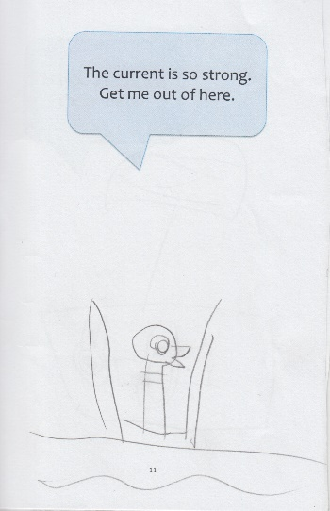
Leah’s ability to depict movement that draws on her visual and linguistic resources has increased in sophistication. In the Story of the stolen crown straight and scribbled lines represent the movements of the evil girl escaping. Other modes and techniques replace these scribbled lines in her later work. In Pigeon goes to the beach she uses onomatopoeia to indicate the bus moving. The bus goes ‘Vroom vroom vroomy vroom vroom’ and is adapted from Willems’ (2003) Don’t let pigeon drive the bus. Movement is shown through body positions, like pigeon’s upside-down dive in Figure 7.

A final word
The interrelationship between Leah’s digital and print literacies is complex. She is a consumer of digital texts rather than a producer, but the influence of the digital looms large in her production of transmedia texts. This would not be possible without being situated in resource-rich social context that provides the time and space needed to engage. Leah enters collaborative play encounters with embodied practices of independence and agency that the digital affords: she doesn’t need adults’ help with her iPad and absorbs messages from a range of semiotic systems. The multimodal nature of the texts and technology she engages with enable her to apply this knowledge to her own multimodal textual representations. What is also clear is the importance of collaboration in the textual playground, the mutual benefits of two players sharing skill sets, and connections forged in the social relationship. Print and digital literacies become entangled through affective engagements with materials and the sensory pleasures they afford. Spatial and temporal organisations mould Leah’s literate habitus as she develops an understanding of the meaning potential of modes, genres, and literary devices.
The methodological decisions we made have enabled us to understand Leah’s embodied literacy practices in particular ways, but limited us in others. We have engaged in our own form of collaborative play, traversing a complex and changing data set that has been beneficial but time consuming in a publication-driven environment. We will need to consider how this ethnography will need to change as Leah’s print literacy grows and new digital engagements reconfigure her play, possibly resulting in a relegated adult playmate. While we are deeply aware of our impact as researchers in the research site, we are also increasingly aware of how the technology we use to record data is used by children for play and appropriated by them. What possibilities and challenges does this present? What embodied practices do researchers need to take on in a world where children are so comfortable with digital technologies and media?

Although the findings of this study can only ever be partial tellings, we have nevertheless tried to show our own sense of wonder at the ‘big worlds’ Leah inhabits.

References
Bearne, E. (2003) ‘Rethinking literacy: communication, representation and text. Reading literacy and language’, November, 98-103.

Bourdieu, P., 1992, Language and symbolic power, Oxford, Polity Press.

Burnett, C., 2010, ‘Technology and literacy in early childhood educational settings: A review of research’, Journal of early childhood literacy, 10(3), 247-270.

Burnett, C., 2015, ‘Being together in classrooms at the interface of the physical and virtual: implications for collaboration in on/off-screen sites’, Learning, Media and Technology, 41(4), 1-24.

Clark. A., & Moss, P., 2011, Listening to young children: the mosaic approach. London, NCB.

Comber, B., 2015, Literacy, place and the pedagogies of possibility, New York, Routledge.

Crescenzi, L., Jewitt, C. & Price, S., 2014, ‘The role of touch in preschool children's learning using iPad versus paper interaction’, Australian Journal of Language & Literacy, 37(2), 86-95.

Dahlberg, G. & Moss, P., 2005, Ethics and politics in early childhood education, London and New York, Routledge.

Dixon, K., 2011, Literacy and the schooled body, London and New York, Routledge.

Dixon, K. & Janks, H., 2016, ‘Exploring representations, identities and relational spaces that young children inhabit’, paper presented at American Education Research Association, San Antonio, 27 April- 1 May.

Dyson, A., 2013, Rewriting the basics: literacy learning in children’s cultures, New York, Teacher’s College Press.

Dyson, A., (ed.) 2016, Child cultures, schooling, and literacy, London and New York, Routledge.

Edwards, S., (2013), ‘Digital play in the early years: a contextual response to the problem of integrating technologies and play-based pedagogies in the early years’, European Early Childhood Education Research Journal, 21 (2), 199-212.

Fairclough, N. 1989, Language and power, London, Arnold.

Fairclough, N. 1995, Critical Discourse Analysis, London, Longman.

Fargas-Malet, M., McSherry, D., Larkin., E., & Robinson, C. 2010, ‘Research with children:
methodological issues and innovative techniques’, Journal of Early Childhood Research, 8(2), 175-192.

Farman, J. 2015, ‘Stories, spaces and bodies: the production of embodied space through mobile media storytelling’, Communication Research and Practice, 101-116

Flewitt, R. 2011, ‘Bringing ethnography to a multimodal investigation of early literacy in a digital age’, Qualitative Research, 11(3), 293-310.

Flewitt, R., Messer, D & Kucirkova, N., 2015, ‘New directions for early literacy in a digital age: The iPad’, Journal of Early Childhood Literacy, 15(3), 289-310.

Foucault, M., 1977, Discipline and punish. The birth of the prison, (A. Sheridan, Trans.) London, Penguin Books.

Foucault, M., 1980, Power/knowledge. Selected interviews and other writings 1972-1977. (C. Gordon (Trans. And Ed.), New York, Harvester Wheatsheaf.

Gallacher, L. and Gallagher, M. (2008) ‘Methodological Immaturity in Childhood Research? Thinking through ‘Participatory Methods’, Childhood 15(4): 499-516.

Harwood, D. (ed.), 2017, Crayons and iPads: learning and teaching of children in a digital world, Thousand Oaks, California, Sage.

Heath, S., Street, B., & Mills. M., 2008. Ethnography, New York, Teacher’s College Press

James, A. & Prout, A., (eds.), 2015, Constructing and Reconstructing Childhood, London and New York, Routledge.

Kress, G., 2004, Reading images: Multimodality, representation and new media. Paper presented at the Expert Forum for Knowledge Presentation, Chicago, IL. Retrieved31 August 2017, from http://www.knowledgepresentation.org/BuildingTheFuture/Kress2/Kress2.html

Larson, J. & Marsh, J., (eds.), 2013, The Sage handbook of early childhood literacy. London, Sage.

Lefebvre, H., 1991, The production of space, Cambridge, MA, Blackwell.

Literat, I., 2013, “A pencil for your thoughts”: Participatory drawing as a visual research method with children and youth’, International Journal of Qualitative Methods, 12(1), 84-98.

Mand, K., 2012, ‘Giving children a ‘voice’: arts-based participatory research activities and representation’, International Journal of Social Research Methodology 15(2), 149–160.

Newfield, D., 2015, ‘The semiotic mobility of literacy’, in J. Rowsell, K, Pahl, (eds.), The Routledge Handbook of Literacy Studies, pp. 267-281, London and New York: Routledge.

Pahl, K., & Rowell, J., 2010, Artifactual Literacies. New York: Teachers College Press.

Rowsell, J. & Harwood, D., 2015, ‘Let it go’: exploring the image of the child as a producer, consumer and inventor. Theory into Practice Journal Special Edition. 54(2), 136-146.

Ryan, M-L., 2012, "Possible Worlds", in: P. Hühn et al. (eds.): The living handbook of narratology, Hamburg: Hamburg University Press. (hup.sub.uni-hamburg.de/lhn/index.php​?title=Possible Worlds​&oldid=1744.

Tay-Lim, J. & Lim, S., 2013, ‘Privileging younger children's voices in research: Use of drawings and a co-construction process’, International Journal of Qualitative Methods, 12(1), 65-83.

Thiel, J., 2014, Literacies, materiality, and working-class lives: Encounters with muchness, PhD thesis, University of Georgia.

Thiel, J., 2015, ‘Vibrant Matter: The Intra-Active Role of Objects in the Construction of Young
Children’s Literacies’, Literacy Research: Theory, Method and Practice 64, 112-131.

Weston Wood Studios, 2010, Don’t let the Pigeon drive the bus [DVD]. United States.

Willems, M., 2004, Pigeon Finds a Hot Dog, New York, Hyperion Books.

Willems, M., 2012, The Duckling gets a cookie, New York, Hyperion Books.

Willems, M., 2003, Don’t let pigeon drive the bus, New York, Hyperion Books.

Wohlwend, K., 2008, ‘Play as a literacy of possibilities: Expanding meanings in practices, materials and spaces’, Language Arts, 86(2), 127-136.

Wohlwend, K., 2009. ‘Damsels in discourse: Girls producing gendered identity texts through Disney Princess play’. Reading Research Quarterly, 44(1), 57-83.

Wohlwend, K., 2015. ‘Making, remaking and reimagining the everyday: play creativity and popular media’, in J. Rowsell, & K. Pahl, (eds.), The Routledge Handbook of Literacy Studies, pp. 548-560, London and New York, Routledge.

