Chapter 3: ‘I didn’t know how to take it a step further’: teachers and young children
becoming critical
Kerryn Dixon and Hilary Janks, Wits University.

Abstract
Freire’s (1972a; 1972b) work shows how adult literacy learners learn to read both the word and the world critically and, in doing so, discover a sense of themselves as agents who can act to transform the social. Our argument in this chapter is that this is also possible for young children. This chapter is based on our work with two early childhood educators teaching in privileged private schools. Both are excellent teachers who invite their emergently literate children to produce multimodal texts (Kress, 2010), extending Freire’s notion of the ‘word’ to include other forms of semeiosis. Both teachers are aware of their students’ privilege and make social justice a focus of their teaching, but neither had had any previous experience of teaching critical literacy. The data gathered raises the issue of the difference between social justice teaching and a critical literacy approach, and what is needed to develop teachers’ critical practice. Children’s text production provides a window into their representations of their worlds and the question for critical literacy teachers is when, whether and how to problematize these constructions in order to help children re-imagine and effect a better world.

Introduction
It is now well established that it is possible to do critical literacy work with young children aged 3 to 9 years, thanks to the pioneering work of Barbara Comber (2001a, 2001b), Allan Luke (Luke et al. 1994), Jennifer O’Brien (1994), Vivian Vasquez (2003, 2014) and those who have followed their lead. Unfortunately, national curricula tend to leave critical literacy for later years, if they include it at all. Our focus in this chapter is on critical literacy work in contexts of privilege in Kindergarten to Grade 3. We will discuss the work of two teachers, one in the U.S. and one in South Africa both of whom work in private schools. We are interested in what it means to do critical literacy work in contexts of privilege because we believe that the burden of change cannot and should not lie entirely with groups who lack power as a result of their social positioning. We also chose to work with teachers who are new to critical literacy in order to understand better the challenges of this approach.

Literature review
There are currently five main paths leading to critical literacy. The first lies in the work of Paulo Freire who, working with adults in Brazil, argued that literacy was about reading both the word and the world in order to change oppressive relations of power. This approach was taken up by Vasquez (2003, 2014) in the U.S. Using critical inquiry methods, she helps her learners to establish their concerns and to investigate options to effect change. The inquiry method forms the backbone of the work of Lewison, Leland & Harste (2008, 2013) at Indiana University.

The second lies in the work of the critical linguists working at the University of East Anglia, England (Fowler, Kress, Hodge & Trew, 1979), and the language and power group working at Lancaster University (Clarke, Fairclough, Ivanič and Martin-Jones, 1990, 1991). This was taken up by Janks (1993) in South Africa, who designed Critical Language Awareness (CLA) materials for use in South African classrooms. Although designed for secondary schools, they were widely used in elementary education in Australia and Canada. Exley, Kervin and Mantei (2015) offer ideas for teaching grammar in Years 3-6 that teachers can build on for critical literacy. Early critical literacy work in Australia that focused on deconstructing everyday texts such as mothers’ day cards (O’ Brien, 1994), toy catalogues (Luke et al., 1994) cereal boxes (Comber & Simpson, 1995) form part of this approach.

Fairclough (1989) went on to focus on language and power and critical discourse analysis (CDA). Marsh and Millard’s (2000) book on using young children’s popular culture in the classroom is underpinned by CDA. Clark and Ivanič’s (1997) work on writing, identity and power laid the foundation for critical writing that extended the field beyond reading. This in turn laid the foundation for working with children as makers of critical texts. Vasquez’s (2014) work shows the making of texts in the service of social action, as does Comber’s (2016) work on place with K-3 teachers.

Australian secondary school teacher educators established the third path using feminist poststructuralist theory to provide a critical orientation to literary texts (Davies, 1989, 2003; Gilbert, 1989). Subsequently critical race theory, queer theory, and post-colonial theory were added to the mix. This critical approach to literature forms the basis of the critical literacy work done on reading picture books. The best examples of this work can be found in the U.S. (Vasquez, 2003; Leland, Lewison and Harste, 2008, 2013). Proponents of Philosophy with Children have also done critical work on picture books using inquiry based methods (Haynes and Murris, 2012) and Evans (2015) has edited a collection of articles on how children respond to challenging and controversial picture books.

The fourth path can be found in Kress’ (2010) work on multimodality. This semiotic turn opened up a wide range of texts that had previously been excluded from literacy education: websites, images in picture books and news articles, classroom spaces, bodies, oral texts, architecture, films, documentaries and so on. As a result, educating critical readers and critical makers of texts is now much more complex. It is as important to look at the art in children’s picture books, as it is to look at the words and for children to think about how they work together to create meaning (Albers et al., 2008). In working with children’s popular culture, Marsh and Millard (2000) explore multimodal texts.

Finally, there is a commitment to engaging with bodies, time and space. Using Bourdieu’s theory of habitus, Luke (1992) shows how young children’s bodies are regulated in literacy lessons. Dixon (2011) examines what happens to children’s bodies as they move from pre-school to Grade 3. She looks at how bodies are ordered by time and in different spaces. Comber and colleagues, building on the work of critical geographers, have developed place-based critical pedagogies (Comber 2016; Comber et al., 2001, 2008).

All of these approaches to critical literacy work with children as consumers and producers of texts. For example, reading texts critically is made easier when we have had practice in making texts. Writers know that they have to think about what to include and exclude; they have to choose their words carefully and they have to decide how to sequence their ideas. They can be taught to find and examine these choices when they read and to apply this knowledge when they write. It is as important for children to have experience in producing multimodal texts. Emergent literates tend in any case to draw on a range of semiotic resources to represent their worlds.

Janks (2010) uses the word ‘design’ as the catch-all word for the making of texts, because it suggests purposeful sign making. While reading is an act of reception and consumption, design is productive. Designing and redesigning texts are creative acts that provide opportunities for social action and transformation. Comber’s (2016) work always provides examples of multimodal texts that children have made. This is also true of our work (Dixon, 2011; Janks, 2010) and that of Vasquez and Felderman (2013) who explore the intersection of critical literacy and new technologies.

These different pathways into critical literacy find a place in Janks’ (2010) book on Literacy and Power. She provides a framework that shows how power intersects with issues of identity and difference, access and exclusion, together with possibilities for effecting transformation through designing and redesigning texts and practices. The framework helps teachers to see how the invisible workings of power can be made visible (Foucault, 1977) and available for scrutiny. She explains how teachers can work with the local politics of everyday (little p politics) and relate them to larger national and international structures of power (big P Politics) (2010, p.186). When children recognise power working negatively in their own lives they can start to figure out what actions they can take to effect change.

Suggested further reading

Luke, A., Woods, A. (2009). Critical literacies in schools: a primer. Voices from the middle, 17(2):8-19.
Luke and Woods provide an extensive review of the field of critical literacy and describe how approaches to critical literacy have been developed in different countries.

Stein, P. (2008). Multimodal pedagogies in diverse classrooms: representations, rights and resources. New York: Routledge
Stein’s book provides teachers with a good understanding of multimodality and how to work with it in classrooms.

Vasquez, V., Tate, S., & Harste, J. (2013) Negotiating critical literacies with teachers: theoretical foundations and pedagogical resources for pre-service and in-service contexts. New York: Routledge
This book provides a simple introduction to working with critical literacy in the early years. The authors explain and provide examples of how to develop critical inquiry out of children’s interests, how to disrupt the taken-for-granted by producing alternative narratives.

Whitin, D & Whitin, P. (2011) Learning to read the numbers: integrating critical literacy and critical numeracy in K-8 classrooms. New York: Routledge and Urbana IL: NCTE
The Whitins show us why numbers need to be interrogated and how to teach children not to take numbers at face value. The authors integrate critical literacy and critical numeracy providing a wide range of interesting examples.

Winograd, K. (Ed.) (2015) Critical literacies and young learners New York: Routledge
This edited collection contains both seminal and new work in the field, illustrating different approaches in a range of contexts. It therefore offers a good introduction to critical literacy.

Stepping into critical literacy: two case studies
One of the challenges for teachers new to critical literacy is finding an appropriate starting point that puts theory into practice, and, is also appropriate for young children. Experienced practitioners like Vasquez (2014) and Comber (2016) make this work look effortless, but it can be what one of our teachers describe as ‘a daunting process’. The first step is recognising social justice issues that emerge from what children say and the texts they produce. This requires critical listening and observation that is alert to children’s constructions of normativity and difference. This is not to say that the teacher cannot introduce social issues through picture books, video clips, current events, or artefacts to find what resonates with the children.

The second step requires a pedagogic move that enables children to respond to the issue. This could, for example, be a discussion, an inquiry, text work, drama, or play. The steps that follow depend on the teacher’s ability to read children’s responses with a critical literacy lens. To do this the teacher has to be able to recognise the social structures of power that systematically produce the inequality evident in children’s responses. Children can see that some people have more than others, and that the world is not fair. What is harder is understanding that privilege has to do with the ways in which society makes it easier for people who are white, middle class, male, beautiful and straight to succeed. It is not about luck; it is about an unfair playing field and the kinds of actions, however small, that can make a positive difference.

We present two case studies of teachers beginning to work with critical literacy and show the ways in which socially conscious work with children can be extended.

Case 1: Debbie
Debbie teaches kindergarten in a Jewish private school in the US. There are only 12 children in her class and they come from relatively affluent homes. Both time and space are central organizing principles of her curriculum. Religious and national holidays affect what she does and when, and she uses them as moments to teach history, culture and values. An exploration of the seven continents of the world provides the remaining curriculum content. The space of the classroom becomes different parts of the world as the class travels around the globe. The decision to work with the continents allows her to include social issues such as overpopulation, the abuse of natural resources, pollution, hunger, cruelty to animals, endangered wildlife and how global warming constitutes a threat to the survival of the planet. Literacy, numeracy, art and song are integrated across the day and much of her pedagogy is play-based. By the time her children move to Grade 1, they can all read.

She makes up songs to well-known tunes to help the children remember what they learn. ‘The Continents’ is sung to the tune of ‘Clementine’ (Figure 1), and ‘Puff the Kosher Dragon’ teaches Jewish values (Figure 2). An extract from the song about Australia, which is sung to the tune of ‘Waltzing Matilda’, can be found in Figure 3 and her Thanksgiving chant in Figure 4. Protecting natural resources are themes in both the Continents and the Australia songs. The children discover the beauty of the coral reefs and they discuss how they are endangered. Being a real kind mensch (Yiddish word for a decenthuman being) is the value that ‘Puff the Kosher Dragon’ teaches and ‘The Continents’ song creates awareness of speaking to people in their own languages. Finally, Thanksgiving opens up conversations on persecution, immigration, and people in search of a better life. Given that migration is likely to remain one of the central human rights issues of this century, teaching children that their ancestors found asylum in the U.S., lays the foundation for greater understanding of the plight of refugees. Issues of change, mobility and responsibility towards others provide a current of social awareness and social justice that flows through Debbie’s work. The songs act in the same way as Vasquez’ (2014) audit trail. At ‘graduation’ Debbie reminds parents of what the children learnt during the year, with a programme of the children singing the songs they learnt across the year.

Figure 1 The Continents | Figure 2: Puff the Kosher Dragon
We all live on planet Earth  And we need to care for her;  Protect her rivers, forests, seas  And the creatures  That live in these.  There are seven large continents  That around our globe are spread  Six of these begin with A  Europe has an E instead.  There’s America, North and South,  Africa and Australia.  The largest continent is Asia,  The coldest one’s Antarctica.  So remember if you travel  To any one of these  Learn the different words  For hello, and for thank you  And for please. | Puff the kosher dragon  Lives on the train line  And frolics in our synagogue  And drinks the cantor’s wine.  Both our special rabbis  Love that rascal Puff  And bring him lox and and matzah balls  And other kosher stuff.  Now you who may be listening  Will think we’re making fun  But deep down in this story  There’s a lesson for everyone.  If a dragon can wear a Kippah  Keep Shabbat and always bensch.  Then you can learn like Puff did  How to be a real kind mensch.

Figure 3 Australia | Figure 4 Thanksgiving
Snorkelling Matilda  Snorkelling Matilda  We’ll come a-snorkelling Matilda  With you.  Among the coral and the dolphins  And pearly oysters in their shells  We’ll come a snorkelling Matilda  With you. | My great great grandparents left on a ship  They sailed and sailed away from Europe  Across, across a very rough sea  Reaching America where they could be free.  So on this holiday, I celebrate a lot  To give my thanks for all that I have got  A home a school, a family who really loves me  And that’s what I’ll be thinking as I munch on my turkey.

Not only does Debbie offer children social justice perspectives, she also shows them how to create perspective in their own art and why perspective is necessary in 2D representations of space. She taught herself how to teach this from the internet (https://za.pinterest.com/maliperriton/to-teach-perspective-drawing/). Essentially you fold a piece of paper diagonally and horizontally. Where they intersect is the vanishing point. (Figure 5)

Figure 5 Finding the vanishing point
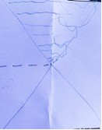

She engaged the children in thinking about how size looks different when objects or people are near or far away, then she modelled drawing trees and houses onto this paper. The children’s perspectival drawings are displayed on the walls of the classroom and the outside hallway in Figure 6.

Figure 6 Children’s perspectival drawings
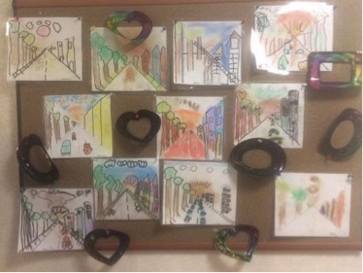
These drawings show that kindergarten children are capable of working in abstract ways, even if they do not have full mastery as can be shown from their drawings of the cars. We would not describe this work on perspective as critical literacy, nor is it meant to be. However, it could be a springboard for children to talk about how where they stand in space literally affects what they see and how they see it. In undertaking an inquiry into spaces designed for adult-size people, for example, children can investigate what this prevents child-size people from seeing and doing. They can also begin to think about how people are positioned by society because of how they speak English, where they live, the clothes they wear etc. These ideas provide scaffolds for children to understand positioning in more abstract ways. For this work, teachers have to understand why positioning is such a key concept in critical literacy.

Debbie and Hilary spent time talking about which of her practices were and were not critical and what critical questions relating to identity and power could be used in teaching Mr Tiger Goes Wild, Peter Brown’s (2013) award winning book. The story tells how Mr Tiger, dressed in a fine suit, walking upright, and always ‘having to be proper’, wanted to ‘loosen up’, ‘have some fun’ and ‘be wild’. As he became wilder – refusing to conform, walking on all fours, climbing buildings, and roaring – his friends did not know what to think. Nevertheless, when he decided to go swimming naked in the town fountain, they sent him out into the wilderness. Mr Tiger had a wonderful time, learning to be a wild tiger but he missed his friends, so he returned to the city. He found that things had changed sufficiently for him to be himself.

Having read the story to the class, Debbie’s questions allowed the children to express their understanding of both the words and the pictures, and to relate the story to their own lives.

Debbie: What do you think the story is about?
Child: To be yourself.
Child: If you’re by yourself maybe you sad.
Debbie: What does it mean to be yourself? When can you and can’t you be yourself?
Child: When I have to do the right thing. Think like other people want me to think.
Child: Maybe when you at a fancy restaurant. Have to be a bit different. When Mommy and Daddy want me to be different,
Debbie: Where do you feel yourself?
Child: At home. I can get out of my seat.
Child: If you want to be yourself, you can’t be with your friends, have to be by yourself.
Child: I don’t feel like myself when it’s somewhere I don’t know. Like when we went to Hawaii. …
Debbie: Where do you feel most comfortable?
Child: At home.
Child: At [school].
Child: I feel myself in Israel and we went to Canada and I don’t feel myself. I felt safe in America but I will feel safer in Israel. With my grandparents. And my dog.
(Intervening discussion on rules at school and being wild).
Debbie: How have they used colour?
Child: They are all brown.
Child: He’s not.
Debbie: Look at their clothes. Gentlemen’s clothes.
Child: I remember. I don’t feel comfortable in my Dad’s boat. I have to go on top. I don’t feel safe there. I don’t like being up there.
Debbie: What else is different about tiger?

Debbie’s class is clearly used to engaging with texts. It is hard in the fast paced interaction of the classroom for any teacher (or, for that matter, a researcher observing and transcribing the lesson) to detect patterns in children’s responses. Two patterns emerge from an analysis of the data, which suggest further opportunities for critical literacy work. First, is that the children do not like being dis-located. Familiarity is what makes them comfortable. Change is un-settle-ing. Their movements across space vary in scale from visiting a nearby restaurant to travelling to a distant State on the other side of the country and beyond, to immigration to Canada then the U.S. and back to Israel. They also vary in duration. The fact that young children have little power over their own mobility and are not always comfortable in the spaces and places that adults choose for them creates an opening for children to explore how decisions that concern them are made and if this is appropriate. It could also lead to discussions about children currently displaced because of war, disease, food security, ‘natural’ disasters, or ethnic cleansing. History teaches us about how Jews through time have had to flee from persecution. What would it have been like for those children? Do the children in Debbie’s class know why their ancestors had to go to America ‘to be free’?

A second pattern is that these children do not recognize their own privilege: fancy restaurants, holidays in Hawaii, the luxury of owning a boat for recreation, even having a good elementary school to go to. Critical literacy teachers in contexts of privilege need to take the opportunities that present themselves to make privilege visible and to denaturalise it. Those of us who are privileged need to understand that we owe ‘what we’ve got’ to social structures that give us an advantage over othered groups who are devalued, marginalised, even reviled, and, who are denied equal access to the jobs and social services that we have, because of who they are. It is not just about having more or less. It is not about being fortunate or unfortunate; it is that society is structured to privilege dominant groups and their ways of being.

The theory that underpins these ideas is taken from the Foucaultian notion of normativity. What counts as normal is often based on the norms of the dominant and is then used as a measure for all. For example, male norms become the bar against which expectations are measured; white norms in South Africa are used to judge African hairstyles as untidy; gender norms are used to justify excluding Caster Semenya from competing as an athlete, adult norms are imposed on children. The list is endless.

It is particularly important for critical literacy to work in contexts of privilege because there is no question that change is made more difficult if those with power and social privilege do not recognize their structural advantage. It is harder to make black lives matter if the privilege of whiteness is not acknowledged by those who benefit from it; or to change the world to be inclusive of gender differences if the male/female binary is seen as natural; or for LGBTIQ identities to be recognized if heteronormatives do not join the struggle; or for the dominance of English, what McKinney (2016) calls ‘anglonormativity’, to give way to the valuing of other languages.

The next step is for the children to discuss instances of discrimination when they encounter them, in their lives, on television, in movies, or in picturebooks. From a position of relative privilege, we have a responsibility to make sure that everyone, everywhere, has the right to fair treatment and respect, equality of education and care, and opportunities to reach their full potential. Debbie links ‘Thanks for all I’ve got’ (see Figure 4) to privilege and the responsibility this entails. The Jewish practices of Tsedakah (the moral obligation of giving) and Tikkun Olam (mending the world) provide the foundation for her children to consider appropriate action to address systemic discrimination and inequality.

Case Study 2: Sandra

Sandra works at an elite private boys’ elementary school in South Africa. On returning to University, she opted for a postgraduate course on Early Literacy. As part of this course we offer some sessions on critical literacy in the early years. We asked the class to choose a page or an activity from Doing Critical Literacy (Janks et al., 2014) and to redesign it to make it appropriate for young children. They were to try the activity with children and record what happened for a class discussion. After the discussion we asked students to engage in this process again. The data presented here are from a Grade 2 and a Grade 3 class.

Sandra is interested in issues of space, time and mobility. The first page she chose was ‘Moving through time and space’ (Janks et al., 2014, p.111) which, using passports, raises questions about how various factors like age, race, income, and politics affect our ability to gain access to certain spaces or to move through them. Many of the boys Sandra teaches travel. Because they had just returned from the school holidays, she thought she could draw on their travel experiences to explore access and mobility.

Travel plans ‘don’t always go according to plan’ as can be seen in this excerpt from the class discussion. One of the boys is talking about airport procedures, when he travelled to Australia.

Michael: We first had to go and get our luggage signed in, I don’t know exactly
what it’s called.…
James: They scan your luggage to see if there is anything dangerous like a gun.
Liam: Sometimes when you go overseas you have to take off your shoes and stuff.
Joe: You also get a scanned thing to tell that you have been out of the country.
Sandra: What’s that called?
Travis: A passport…..
Sandra: Michael, what would have happened if you’d arrived at the airport to go to Australia and you didn’t have your passport?
Liam: You could ask your gardener or your au pair to take a picture of it and send it to you and then you can get on the plane.
Sandra: The Australian government wouldn’t allow that.
Michael: No, I couldn’t have got on the aeroplane, I’m pretty sure I would have to go home or had to argue it out.

Following this discussion Sandra invited the boys to make passports for themselves (see Figure 7).
Figure 7 Passports made by two boys
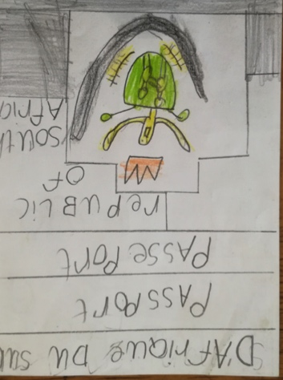 | 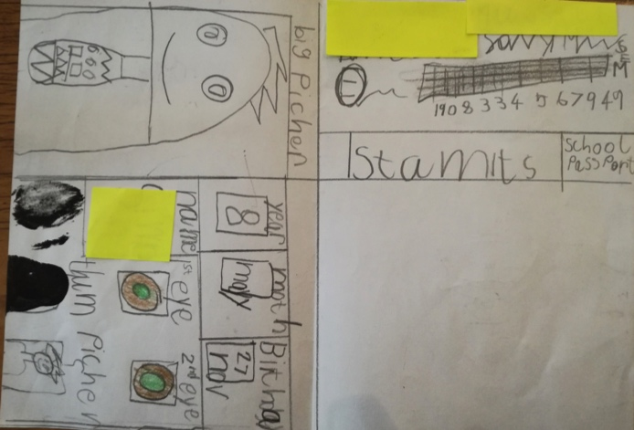
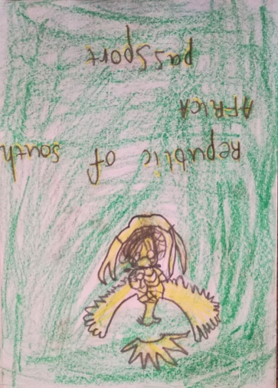 | 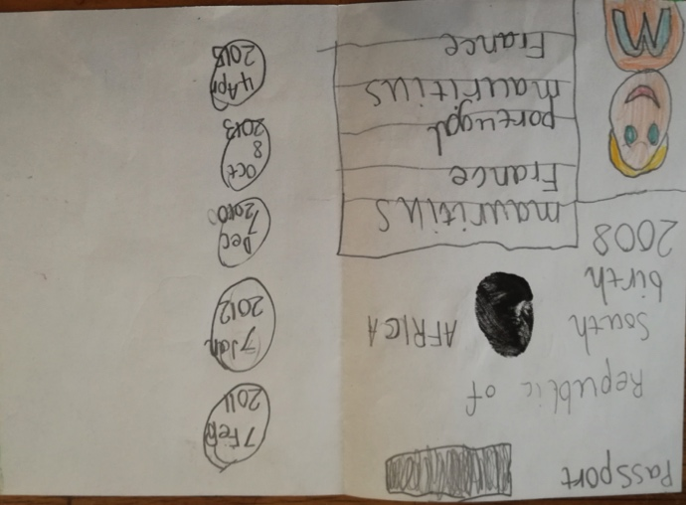

The challenge for Sandra was knowing that she wanted to problematize the boys’ invisible, normalised, privileged ways of reading the world but that she was not sure how to do this. In reflecting on the lesson and the class discussion, Sandra talked about struggling to ask critical literacy questions to extend the boys’ thinking:

I didn’t know how to take it that step further where you ask, who’s included and who’s excluded, and why, and then how could the children be given agency to make a difference? My frustration with our little ‘elitist bubble’ is always that our children have no point of reference. The one boy, who genuinely thought that everyone in the world had travelled on an aeroplane, has a home and owns a bicycle, doesn’t know any better.

Sandra can see the boys’ unconscious, privileged view of the world and how this manifests as entitlement. Gardeners and au pairs are seen as ‘normal’ part of life and they are expected to be available to sort out problems. Michael assumes that he can ‘argue it out’ successfully, even though he has not followed the rules; he can talk his way out of any situation. This could be read as naiveté about what passports as texts represent. But, it also speaks to the self-confidence privilege brings and to a disposition of entitlement. What Sandra is not sure of is how to disrupt what the boys take for granted. Vasquez at al. (2013, p.8) argue that this is precisely what is difficult in a critical literacy approach. As in the case of Debbie, teachers have to work to make what is invisible to the children visible, and to help them see that what is normal for them is not normal for everyone. It is a mark of their privilege and their cultural capital (Bourdieu, 1991).

The passports, in Figure 7, reveal the boys’ cultural capital. They know that South African passport covers are in English and French, that they include a photograph, names, date of birth and address, as well as barcodes for scanning. Particularly revealing is their awareness of multiple entry and exit stamps. They know that to get a passport you need to provide biometric information. They haven’t understood that this information is captured by the barcode and so they incorrectly include fingerprints and retinal scans in their texts.

One of the advantages of texts, as opposed to the immediacy of classroom discussion, is that teachers can take time to consider the possibilities that emerge from what the children have produced. Where children are making a generic text, such as a passport, it is always possible to invite them to think about the purpose of the text, why the genre is the way it is, and whose interests it serves. This might result in questions like: why is South Africa written in French on the passport covers, given that South Africa has eleven official languages and none of them is French? Why is biometric information needed for passports? What happens with this information? Why do passports have photographs? What do the immigration stamps say about the passport holder’s access to countries? Who decides where we can and cannot travel? What does a record of travel tell people? Is this a good thing? Is this a bad thing? Can everyone have a passport?

What did happen in this lesson is that the children discussed access to a children’s playground that they frequent and the cultural capital needed to book and pay for these tickets online. Sandra helped her class to consider the material resources needed for this form of entertainment, that are not available to everyone. While it is important to listen to children and to allow them to take the discussion where they want it to go, it is also important to know when to pause in order to build on the critical issues that emerge from their talk. Teachers need time to reflect on the opportunities for critical literacy work that they may have missed, in order to prime themselves for future opportunities.

For her second attempt she chose to work with ‘Time, space and bodies’ (Janks et al., 2014 p. 106). She wanted to get the boys to think about the school day in relation to time and space. The boys were given a copy of their school timetable, which they used to complete a survey (Figure 8) and to draw mobile maps of their movements across the time and spaces of the school day.

Figure 8 Example of a completed survey
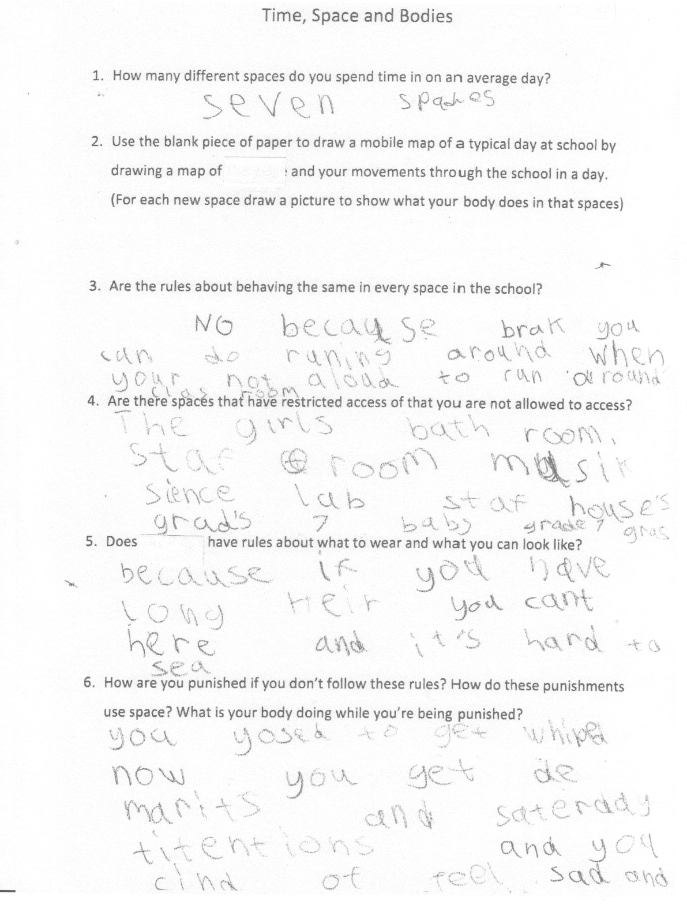

Below is some of the discussion on restricted spaces from question 4 in the survey.
Sandra: Why do you think that you are not allowed on the Grade 7 grass?
Chase: It’s the senior grass.
Mitch: It’s a privilege.
Sandra: What does that mean?
James: It means, well, they actually, they…basically you’re not allowed, cause it’s their grass.
Sandra: And what happens to you if you do go on the grass, MC?
Mitch: They make you do push-ups.
Sandra: Is that fair?
Mitch: Yes.
Sandra: Who else thinks it’s fair?
(eruption of responses)
Noel: It’s not fair cause they get two grasses and we only get one, the big field.
Dan: It’s actually quite fair for the Grade 7s to have their own grass cause they’ve been in the school for quite a long time.
Sean: I think it’s fair because they have been at the school for 8 years and I think they get the privilege of getting their own grass because it’s like a prize for being at the school for so long.
Brendan: My mom did something like this and she said everyone should be treated equally in every single environment.
Sandra: So should the adults and the children be treated equally in every environment?
Brendan: Yes.

In this discussion Sandra asks questions that are more critical than before. She asks about privilege, fairness and the consequences of challenging privilege. What she does not do is share with the boys her knowledge that there are no official rules reserving this space for Grade 7s. Knowing this she might have asked the boys what made them think this was a restricted space; what made them believe that the older boys had the right to make them do push-ups if they were caught in the space. Or, she could have told them that there is no rule, and asked them if this changes anything. To do so Sandra would have had to break her complicity with the adults’ unofficially sanctioning the older boys’ power in relation to this space. She would have had to have been willing to help the boys talk about the difference between power given and power assumed, as well as the possible actions available to them. All this with the recognition that social action does not always bring about structural change.

In these small daily moments in the lives of privileged school boys, the experience of being excluded from a space by an implicit, tacitly understood rule, with no clear reason for it being so, is an example of small p politics. This experience is an entry point to talk about big P politics and the relationship between access, power and space that affect the lives of millions of people every day.

Follow up activities
1 Travelling to Australia
Re-read the transcript of the boys talking about going to Australia.
What questions could you ask that would make this a critical literacy lesson? What specific issues would you want to focus on to help the boys reimagine the world? What texts could you use for this re-imagining? (These may be teacher resources or texts the children design/make themselves?)
2 Leading a critically literate life
In their book Negotiating Critical Literacies with Teachers, Vasquez, Tate and Harste (2013) talk about teachers’ reflecting on their own assumptions, their own positions on social issues, their own beliefs, values and practices with regard to leading ‘critically literate lives’. Examine what it would mean for you to take up critical literacies in your own life in and out of school.
3 Read Mr Tiger Goes Wild and examine the ways in which the words and the pictures position Mr Tiger and the animals in the town. What questions would you ask children to make them think critically about questions of power, access, identity and diversity?
4 Identify Big P or little p issues that the children in your early years class could relate to. How could you work with these issues in your classes? What texts or activities might you choose to do this work?
5 Debbie asked the children in her class to ‘Draw a place where you can be yourself’. (See Figure
10). Below are four of the children’s drawings and their oral explanations of them. How would you use these drawings as the basis for further critical literacy work?

Figure 10: Children’s drawings of places they can be themselves
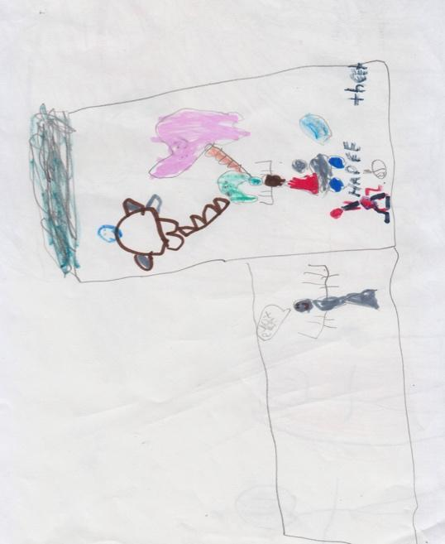 | 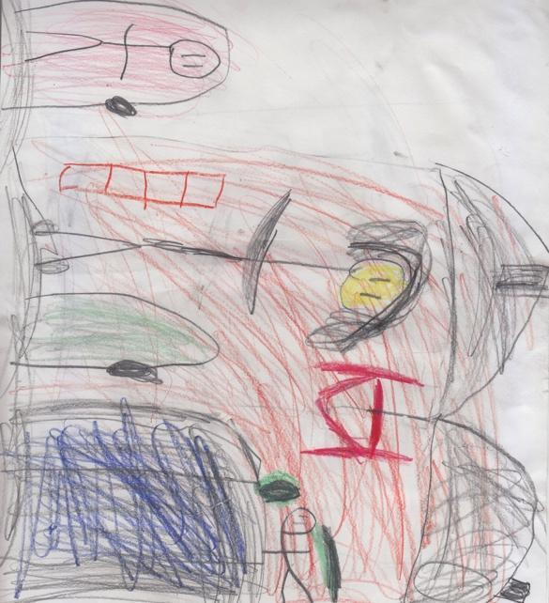
When I am going into Skylanders fighting chaos in my apartment and my Mom says ‘Please don’t’. | Me and my room and sleeping with my blanket over my head.
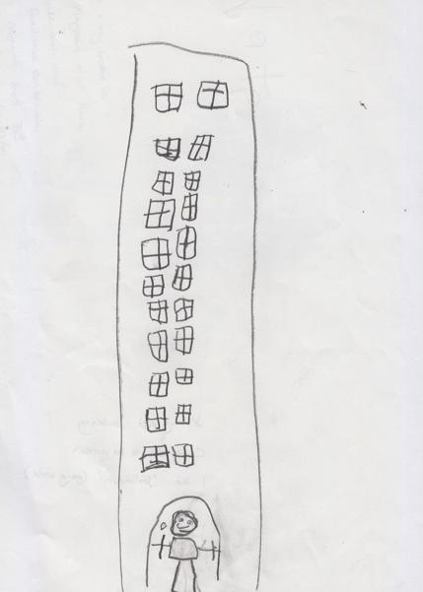 | 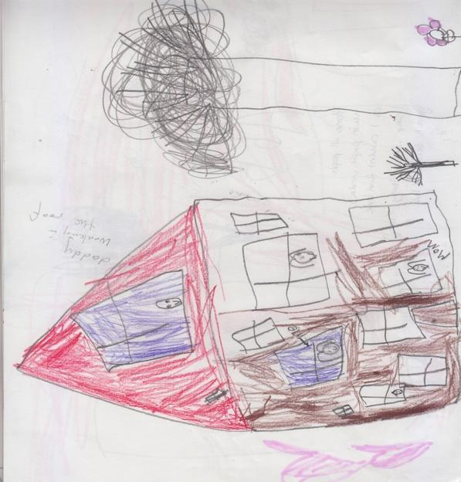
In my apartment building and going out to the garden. I like balagan (chaos). | Home. All people. Me in purple window as I couldn’t find blue. I sleep with my lovey giraffe.  [Dad fixing the roof; Mom ground floor right, ‘Me’ upstairs left].

Conclusion
Working with teachers new to critical literacy has made us think about the theoretical and practical resources we drew on to imagine what Sandra called ‘the next steps’. We came to understand that to work effectively with a critical orientation, it is not enough to have a social justice disposition. One needs theoretical resources and an understanding of power as structural. Critical literacy is an approach to education that asks teachers and children to consider important ethical questions with the ultimate aim of producing agentive citizens who can act to effect change for the better. Learning how to ask critical questions that push children’s understanding of social structures that oppress or advantage them is not easy.

Because most people are not equally empowered in all of their subject positions, teachers can ask children to examine their own positions to see where they feel they have some power, and where they do not. Working from children’s sense of empowerment or disempowerment, teachers can build empathy for others and help them to deliberate on possible action. But this is best done, in relation to the concerns they raise in what they say, how they play, and what they make, write and draw. We need to be alert to the critical issues that emerge as we watch and listen to children.

In a recent interview Meryl Streep said about male actors supporting women actors’ right to equal pay

That's the best vigilance: the vigilance of privilege ... When the other side says, 'You know I think that sucks', that's great" (Lansky 2016 p. 39).

What this entails is that those who are privileged recognize their own privilege as unjust and contribute to change. It is simply not enough to expect those who are structurally disadvantaged to act alone. Transformation is the responsibility of everyone, including children.

References

Albers, P., Vasquez, V., Harste, J. 2008. A classroom with a view: teachers, multimodality, and new literacies. Talking Points 19(2): 3-13.

Bourdieu, P. (1991) Language and Symbolic Power. Oxford: Polity Press.

Brown, P. (2013) Mr Tiger goes wild. London: Macmillan Children’s Books.

Clark, R., Fairclough, N., Ivanič, R., & Martin‐Jones, M. (1990). Critical language awareness 1 part I: A critical review of three current approaches to language awareness. Language and Education, 4(4), 249-260.

Clark, R., Fairclough, N., Ivanič, R., & Martin‐Jones, M. (1991). Critical language awareness 1 part II: Towards critical alternatives. Language and Education, 5(1), 41-54.

Clark, R., Ivanič, R. (1997). The politics of writing. London: Routledge.

Comber, B. (2001a). Critical literacy: power and pleasure with language in the early years. Australian journal of literacy 24(3):168
Comber, B. (2001b). Negotiating critical literacies. School Talk 63:1-2.
Comber, B. (2016.) Literacy, place and pedagogies of possibility. New York: Routledge.
Comber, B., Simpson, A. (1995) Reading cereal boxes. Broadsheet, Texts: The Heart of the English Curriculum, 139-149.
Comber, B., Thomson, P., & Wells, M. (2001). Critical literacy finds a" place": Writing and social action in a low-income Australian grade 2/3 classroom. The Elementary School Journal, 451-464.
Comber, B., Nixon, H., Ashmore, L., Loo, S., & Cook, J. (2006). Urban renewal from the inside out: Spatial and critical literacies in a low socioeconomic school community. Mind, Culture, and Activity, 13(3), 228-246.
Davies, B. (1989). Frogs and snails and feminist Tales. NSW, Australia: Allen & Unwin.
Davies, B. (2003). Shards of glass: Children reading and writing beyond gendered identities (2nd ed.). Cresskill, NJ: Hampton Press.
Dixon, K. (2011). Literacy, power and the school body. New York: Routledge.
Evans, J. (2015). Challenging and controversial picture books. London: Routledge.
Exley, B., Kervin., Mantei. J., (2015). Exploring with grammar in the primary years. Norwood SA: Australian Literacy Educators Association.
Fairclough, N. (1989). Language and power. London: Longman.
Foucault, M. (1977). Discipline and punish. London: Penguin.
Freire, P. (1972a). Cultural Action for Freedom. Harmondsworth: Penguin.

Freire, P. (1972b). Pedagogy of the Oppressed. Harmondsworth: Penguin.

Gilbert, P. (1989). Gender, literacy and the classroom Carlton, Victoria: Australian Reading Association

Haynes, J., Murris, K. (2012). Picturebooks, pedagogy and philosophy. New York: Routledge.

Janks, H. (Ed.) (1993). Critical Language Awareness Series. Johannesburg: Hodder and Stoughton and Wits University Press.

Janks, H. (2010). Literacy and power. New York: Routledge.

Janks, H., Dixon, K., Ferreira, A., Granville, S., & Newfield, D. (2014). Doing critical literacy: texts and
activities for students and teachers. New York: Routledge.

Kress, G. (2010). Multimodality: A Social Semiotic Approach to Contemporary Communication. London
and New York: Routledge.

Fowler, R., Hodge, B., Kress, G., & Trew, T. (1979). Language and control. London: Routledge and Kegan Paul.

Lansky, S. (2016). Off-key, but on point. Time August 22. pp36-39.

Lewison, M/. Leland, C., & Harste, J. (2008). Creating critical classrooms. New York: Lawrence Erlbaum
Associates

Leland, C., Lewison, M., & Harste, J. (2013). Teaching children’s literature. Its critical! New York: Routledge.

Luke, A. (1992). The body literate: Discourse and inscription in early literacy training. Linguistics and Education, 4(1), 107-129.

Luke, A., O'Brien, J., & Comber, B. (1994). Making community texts objects of study. The Australian Journal of Language and Literacy. 17(2), 139.

Marsh, J., Millard, E. (2000). Literacy and popular culture: using children’s culture in the classroom. London: Sage.

McKinney, C. (2106). Language and power in post-colonial schooling: ideologies in practice New York: Routledge.

O’Brien, J. (1994). Show mum you love her: taking a new look at junk mail. Reading, 28:43-46.

Vasquez, V. (2003). Getting beyond ‘I like the book’: creating space for critical literacy in K-6 classrooms.
Newark, DE: International Reading Association.

Vasquez, V. (2014). Negotiating critical literacies with young children. (10th Anniversary Edition). New York: Routledge.

Vasquez, V., Feldman, C. (2013). Technology and critical literacy in early childhood. New York: Routledge.

Vasquez, V., Tate, S., Harste, J. (2013). Negotiating critical literacies with teachers: theoretical foundations and pedagogical resources for pre-service and in-service contexts. New York: Routledge.

Winograd, K. (Ed.) (2015) Critical literacies and young learners New York: Routledge

